

The Deafblind – Introductory Training Course:
learner experiences, reactions and results

A research report commissioned by SensesWA

Dr Meredith Prain
Ms Gemma White
Prof. Keith R. McVilly

August 2026
Authorised:
SensesWA (ABN: 93 1691 951 27)
4 / 20 Parkland Rd, Osborne Park, Western Australia, 6017
PO Box 1088, Osborne Park DC, Western Australia, 6916
Telephone: 1300 111 881
E-Mail: customerservice@senses.org.au
Web: https://www.senseswa.com.au/

This project was commissioned by SensesWA (lead organisation of Deafblind Information Australia), a not-for-profit organisation originating in 1895. Senses’ stated purpose is to build capacity and capability to open a world of opportunity for people with disability across the lifespan. They specialise in services for those who are Deafblind and those with other sensory related disabilities.
Copyright:
© 2026 SensesWA and the University of Melbourne.
This publication is copyright, apart from any use as permitted under the Copyright Act 1968, or by individuals for study purposes; no part of this publication may be reproduced without permission. In all cases the source of the material must be acknowledged when reproducing or quoting any part of this publication.
Suggested citation:
Prain, M., White, G., and McVilly, K. (2026). The Deafblind – Introductory Training Course: learner experiences, reactions and results. A research report commissioned by SensesWA. University of Melbourne, School of Social and Political Sciences, Melbourne, Victoria, Australia.
Acknowledgements:
We acknowledge the traditional owners of the lands on which this research was conducted and pay our respects to their elders past and present.
We thank Steve Rose, Project Officer with Able Australia for his assistance, and the people with disability, family members and service providers who contributed to this work.
Contents
Note on terminology 3
Executive Summary 4
Introduction 6
The project 6
The course 6
The evaluation model 13
The method of research and evaluation 14
Results 15
Participant demographics 15
Quantitative findings 20
Qualitative findings 26
Discussion 41
The need for a course on deafblindness 41
Learning design 42
Transfer of learning and behaviour change 43
Getting results 44
Conclusion 44
Limitations 45
Recommendations 45
References 47
Appendices 48
Appendix A Statistical analysis of quantitative survey data 48
Appendix B Summary of themes 50
Appendix C Participants suggestions for course content improvement 51

Note on terminology
aNewSpring - This is both the registered trademark and product name for the Learning Management System (LMS) used for the Deafblind – Introductory Training Course.
Deafblind – There are more than twenty terms used interchangeably with 'deafblind/ness', e.g. deaf-blind, deaf and blind, dual sensory loss, combined vision and hearing impairment (Wittich et al. 2013). Deafblindness is present in anyone who is Deaf or has any degree or type of hearing loss and also has any degree or type of vision impairment or blindness (SensesWA 2026).
‘Deafblind’ is written as one word denoting it is a distinct disability with defining features rather than simply blindness plus deafness combined. There are an increasing number of Australians identifying as Deafblind (with a capital 'D') and belonging to the Deafblind community, including participants who contributed data for this evaluation. However, most Australians with both vision and hearing loss, who fit the functional definition of deafblindness, do not identify as being 'Deafblind'.
The leading cause of deafblindness is ageing, and those with age related vision and hearing loss are most commonly referred to as having ‘dual sensory loss’ or ‘dual sensory impairment’ (Wittich and Dumassais 2026). While recognising that people and families living with deafblindness identify in many different ways, 'deafblind' with lower case 'd' will be used throughout this report unless at the start of sentences or when referring to the course.
Deafblind – Introductory Training Course (DB-ITC) - This is the full title of the course under evaluation in this report. Throughout the report the course may be referred to as the 'DB-ITC' or 'the course'.
Deafblind Information Australia - a consortium of SensesWA, Able Australia and Deafblind Australia, with SensesWA being the lead organisation. Deafblind Information Australia manages a website with current evidence-based information about deafblidnness and delivers workshops and other activities related to deafblindness across Australia.

Executive Summary
The Deafblind – Introductory Training Course (DB-ITC) was developed by Deafblind Information Australia in 2025. The University of Melbourne was commissioned by SensesWA to undertake an evaluation of the DB-ITC over two iterations of the course.
Pre and post course surveys were completed by learners across two cohorts, which generated quantitative and qualitative data. Further qualitative data were generated through post course interviews.
A statistical analysis of the quantiative data was undertaken, and a thematic analysis of the qualitative data was undertaken using a priori codes from the Kirkpatrick framework – a well-established 4-tier framework for the evaluation of educational interventions.
Course participants were from across Australia, with varying ages and levels of experience and representing a range of sectors including disability, health and education. Participants also brought a range of perspectives from their experience including the perspective of those with lived experience of deafblindness, family members, service providers and educators.
The quantitative data revealed high levels of satisfaction with the course and that all learners regardless of their level of pre-course professional experience perceived an increase in their knowledge on deafblindness across a range of areas including communication, orientation and mobility, and congenital and acquired deafblindness.
The qualitative data indicated that learners had favourable reactions to the course and particularly liked the self-paced / on demand aspect, and the course's accessibility and multi-modal learning features. Learners also demonstrated learning new knowledge and skills and some were already applying this learning in their various workplaces soon after completing the course.
Furthermore, participants reported aspects of the course that they perceived as favourable and suggested improvements to support the further development of the course, course activities and assessment design.
Key considerations for future policy and practice with respect to the implementation of similar professional development programmes include the development of organisational strategies designed for maximising the transfer of learning to the workplace, demonstrating the value of training to organisations, addressing challenges associated with supporting professional development within complex environments, and understanding the impacts of related programs and policies from diverse perspectives, including those for whom the programs are intended to benefit, namely persons with deafblindness.

Introduction

The project
SensesWA, a not-for-profit organisation specialising in services for people with deafblindness and those with other sensory related support needs, identified the need for a specialist training course to support staff delivering services to deafblind people. The University of Melbourne was asked to undertake a research evaluation of effectiveness of the course.
The project was conducted over a 12-month period, to evaluate two rounds of the training program.

The course
The Deafblind Introductory Training Course (DB-ITC) was developed to provide a structured, accessible introduction to deafblindness for support workers, health, and allied health professionals, educators, family members, NDIS staff and other supporters of people with deafblindness. The course development process commenced with a comprehensive review of comparable international deafblindness training programs benchmarked equivalent to Certificate I–IV level (Australian Qualification Framework). Learning outcomes from these courses were mapped and analysed to identify common knowledge and skill areas. These findings informed the development of draft learning outcomes for the DB-ITC, which were refined through stakeholder consultation. Deafblind Information Australia (DBIA) resources were mapped to the learning outcomes. Content was reviewed to ensure alignment with the finalised outcomes, and additional material was commissioned to address identified gaps.
The pilot course was designed as a 40-hour online training program comprising eight modules, with content sequenced to support progressive learning. The nominal hours of learning and associated activities were bench-marked against the requirements of a micro-credential at the University of Melbourne; i.e., 25% of an Australian Qualifications Framework (AQF) level 8/9 masters degree level subject.
Assessment activities and practical learning tasks were embedded throughout the course, alongside pre-course, mid-course and post-course knowledge probes to measure learning and knowledge development. A post-course evaluation framework was developed to gain both quantitative and qualitative feedback on the course. Prior to piloting the course, it underwent a detailed review by four Deafblind Information Australia project officers to assess both content quality and accessibility. Accessibility was a core design principle throughout development, with all videos Auslan interpreted and accompanied by transcripts, high colour contrast incorporated across the learning platform, and content designed to be compatible with screen reader software.
Academy of Healthcare, a registered training provider was commissioned to host the course on the aNewSpring Learning Management System, and a pilot Cohort was enrolled in the course. The pilot Cohort involved 17 participants, who provided feedback that informed subsequent iterations.
The pilot Cohort feedback initiated a comprehensive review by an accessibility consultant to identify further access enhancements. However, there were limitations to the Learning Management System, which have since been raised with platform developers. Subsequently, the accessibility consultant developed some access work arounds.
Communicate with Deafblind people, is a current unit of competency forming part of the Public Service Training Package. This unit was last updated in 2018 (Australian Government 2018). A review of the Auslan, Interpreting and Translating qualifications is currently underway (Public Skills Australia 2026). The DB-ITC learning outcomes and objectives are broader than the Communicate with Deafblind people unit, and were developed to address the gaps in the existing unit of competency. The DB-ITC modules, learning outcomes and objectives are presented in table 1 below.

Table 1 Deafblind – Introductory Training Course Module name, Learning Outcomes and Learning Objectives.
Module name | Learning Outcomes | Learning Objectives
- Understanding deafblindness | - Participants can define deafblindness  - Participants can describe types, causes and the unifying features of deafblindness | 1.1 Name parts of the ear and their role in hearing  1.2 Name parts of the eye and their role in vision  1.3 List eight different senses and what they do  1.4 Name key life spaces in the life space model  1.5 Name different environmental modifications that increase access to information and independence
- Accessibility | 2.1 Participants are aware of environmental modifications and use of assistive technology to support access and independence.  2.2 Participants understand the impacts of combined hearing and vision loss (deafblindness and other sensory disabilities) on the individual | 2.1 Participants can demonstrate knowledge of the broad range of face-to-face communication methods used by people with deafblindness  2.2 Participants will be able to state the non-language features of a high-quality interaction, (for all stages of development including in the tactile mode)
- Communication | 3.1 Participants can demonstrate knowledge of the broad range of face-to-face communication methods used by people with deafblindness  3.2 Participants will be able to state the non-language features of a high-quality interaction, (for all stages of development including in the tactile mode) | 3.1 Name and identify different ways to communicate used by the deafblind community  3.2 Practice the deafblind manual alphabet and block alphabet to be able to introduce yourself  3.3 Describe the features of high-quality interactions  3.4 Name how key features of high-quality interactions are expressed in the tactile mode
4. Orientation and Mobility | 4.1 Participants can identify safe guiding techniques to support people with deafblindness | 4.1 Describe key concepts in orientation and mobility  4.2 List a range of orientation and mobility aids available to people with deafblindness  4.3 identify key adaptations to consider when guiding a deafblind person  4.4 Define the roles of O&M specialist, Communication guide, human and dog guide  4.5 Practice guide techniques and communication messages used when guiding a person
5.Acquired Deafblindness | 5.1 Participants can identify the impacts of acquired deafblindness and strategies to address them | 5.1 List common impacts of acquired deafblindness  5.2 Describe strategies to address common impacts  5.3 List common technologies required for independence
6. Congenital Deafblindness | 6.1 Participants identify the impact of congenital deafblindness on learning and development | 6.1 List common impacts of congenital deafblindness  6.2 Describe strategies to address common impacts  6.3 List common resources used in active learning
7. Person Centred Support and Independence | 7.1 Participants can identify barriers to participation and independence for people with deafblindness and strategies to address these barriers to optimise engagement, participation and independence | 7.1 List barriers to participation for people with deafblindness  7.2 Name strategies to foster engagement, participation and independence  7.3 Do a task analysis of an everyday activity, identifying components that can be done independently, with a prompt or will full hand-under-hand support  7.4 Practice using the hand under hand mediation approach with a partner
8. Policy and funded supports | 8.1 Participants can name legislation and funded supports relevant to Australians with deafblindness and the ethical considerations for service providers | 8.1 List key legislation relevant to supporting the rights of people with deafblindness  8.2 Name and describe the function of different professional roles  8.3 Participants identify responsibilities and issues in professional practice

The evaluation model
This project was informed by the Kirkpatrick Evaluation Model, originally developed in 1952 and since revised (Kirkpatrick and Kirkpatrick 2016).. It is a widely recognised framework in the peer-reviewed literature for assessing the effectiveness of training programs. It evaluates training at four levels:
LEVEL 1 (Reaction): The learners’ reactions to the training. At this point in the evaluation, the focus is on how favourable, engaging and relevant the learner found the training experience. Here it should be noted that recent research suggests the key issue is the extent to which the learner found the training relevant to their work. Relevance has been found to be the stronger predictor of the likelihood of the learner applying their learning when they return to work. This element of the model is commonly evaluated using in-session polls, post-training surveys, interviews, and focus groups.
LEVEL 2 (Learning): The degree to which participants acquire the intended knowledge, skills, attitude, confidence and commitment based on their participation in the training. At this point in the evaluation, the focus is on the extent to which learners develop new knowledge or skills (“I know it, I can do it”), the extent to which their attitude (“I believe it is worthwhile”) and confidence (“I will do it”). Both these latter factors have been demonstrated to be strong predictors of whether the learner will change their workplace behaviours on return to work (i.e., Level 3 behaviour). This element of the model is commonly evaluated using short quizzes and written tests together with opportunities to demonstrate skills in simulation or role play. Case study and scenario-based questionnaires can also be used.
LEVEL 3 (Behaviour): The learners’ workplace behaviours: At this point in the evaluation the focus is on the extent to which there is evidence of the learner transferring what they have learnt into their everyday workplace practices. However, recent research suggests that even the best training fails if certain conditions are not present in the workplace. These conditions include the learner’s own desire to change practices, remembering (and being reminded) of what they have learnt, together with the right climate (e.g., a supportive manager / workplace supervisor who removes obstacles to the application of the new knowledge, coaches learners in their application of new knowledge, and rewards learners for applying their new knowledge). This element of the model is commonly evaluated using self-report, supervisor reports, and direct observation.
LEVEL 4 (Results): The learners’ achievement of results: At this point in the evaluation, the focus is on what happens in the workplace as a consequence of the learners’ application of their training; what changes or what improves. This could relate to levels of productivity, decreases in adverse events, or improvements in client outcomes. In the past, this has often been couched in terms of ‘return on investment’ (ROI). However, it is now acknowledged that changing circumstances in the workplace are complex, and training can only be considered one ‘input’ to an ROI equation. It is therefore recommended that in addition to outputs and outcomes, results are also evaluated in terms of ‘return on expectations’ of workers and their managers.

The method of research and evaluation
The protocol for this research project was reviewed and approved by the University of Melbourne Human Research Ethics Committee; Reference: 33934.
The project aims were to address these research questions:
- Does the Deafblind – Introductory Training Course change (increase) the knowledge and understanding that program participants have of best practice approaches to working with people who are deafblind?
- Does the Deafblind – Introductory Training Course change (increase) the skills of program participants in understanding deafblindness and supporting people who are deafblind to access information and environments, communication, navigating the built environment and the experiences of people with congenital and acquired deafblindness.
- What indicators and outcomes (i.e. reactions, learning, behaviour and results) are achieved for program participants as a consequence of participating in the course?

Participants were recruited through the Deafblind Information Australia communication channels; mailing list and social media. Then, to address the research questions, the Kirkpatrick framework was used to assist in framing the data. The project was primarily qualitative in its ontology. It applied the Kirkpatrick model through a series of surveys and interviews involving learners prior to and following their undertaking the course.
The analysis was conducted over two cohorts, and the final discussion and recommendations arose from a synthesis of these analyses.
For each cohort, on-line surveys were conducted consisting of 39 total questions (five demographic and three quantitative pre-survey questions, and; 25 quantitative and six qualitative post-survey questions).
Semi-structured interviews were conducted with a purposive sample of nine participants who represented various roles, sectors and levels of experience, and included one participant who did not complete the course, in order to gain insights into reasons for course abandonment. The interviews focused on the core issues for the evaluation but with sufficient latitude for participants to comment as they thought relevant. Each interview was estimated to take about 30 minutes.

Results

Participant demographics
Of the 50 participants in the first course evaluation, a total of 49 (98%) people participated in the pre-course survey and 34 (68%) in the post-course survey. All 28 participants from the second cohort completed the pre-course survey and 15 (54%) from this cohort completed the post-course survey.
Participants were mostly aged between 18 and 65 years old with just two being over 65, and all States and Territories but Tasmania and the Australian Capital Territory were represented. A range of sectors and professions were represented including professionals working in early intervention, disability and education, though no participants worked in aged care or research. Four people with deafblindness and five family members participated.
The following tables present the demographic data for participants in both cohorts 1 and 2. Table 2 presents the demographics for the survey participants. Table 3 presents the demographics for the interview participants combined across cohorts 1 (N=50) and 2 (N=28).

Cohort 1 and 2 survey participants
Table 2 Participant characteristics reported in the on-line surveys
Participant Characteristics | Cohort 1 |  | Cohort 2 |  | Total
Participant Characteristics | N | % | N | % | N | %
Age
18 – 30 | 13 | 26 | 3 | 11 | 16 | 21
30 – 45 | 14 | 28 | 7 | 25 | 21 | 27
45 – 65 | 23 | 46 | 16 | 57 | 39 | 50
65+ | 0 | 0 | 2 | 7 | 2 | 3
Total participants | 50 | 59 | 28 | 33 | 78 | 100
State or Territory
ACT | 0 | 0 | 0 | 0 | 0 | 0
NSW | 10 | 20 | 11 | 39 | 21 | 27
NT | 2 | 4 | 0 | 0 | 2 | 3
QLD | 16 | 32 | 2 | 7 | 18 | 23
SA | 0 | 0 | 1 | 4 | 1 | 1
TAS | 0 | 0 | 0 | 0 | 0 | 0
VIC | 12 | 24 | 8 | 29 | 20 | 26
WA | 10 | 20 | 6 | 21 | 16 | 21
Sector*
Early Intervention | 22 | 44 | 3 | 5 | 25 | 17
Education | 22 | 44 | 4 | 7 | 26 | 17
Disability (not schools) | 25 | 50 | 21 | 38 | 46 | 31
Disability Employment | 6 | 12 | 4 | 7 | 10 | 7
Healthcare | 8 | 16 | 4 | 7 | 12 | 8
Aged care | 2 | 4 | 4 | 7 | 6 | 4
Academia | 0 | 0 | 4 | 7 | 4 | 3
Advocacy | 9 | 18 | 12 | 21 | 21 | 14
Role*
Person with deafblindness | 0 | 0 | 3 | 11 | 3 | 4
Family member | 3 | 6 | 2 | 7 | 5 | 7
Support worker | 1 | 2 | 1 | 4 | 2 | 3
Communication Guide | 1 | 2 | 2 | 7 | 3 | 4
Allied health professional | 26 | 52 | 7 | 25 | 33 | 45
Educator | 12 | 24 | 3 | 11 | 15 | 21
Aged care worker | 0 | 0 | 0 | 0 | 0 | 0
Employed by NDIA | 4 | 8 | 0 | 0 | 4 | 5
Researcher | 0 | 0 | 0 | 0 | 0 | 0
Advocate | 3 | 6 | 1 | 0 | 4 | 5
Professional (Other)** | 4 | 8 | 0 | 4 | 4 | 5
Years of experience working with DB
0 | 9 | 18 | 3 | 11 | 29 | 15
0-2 | 15 | 30 | 4 | 14 | 44 | 22
2-5 | 8 | 16 | 4 | 14 | 30 | 15
5-10 | 9 | 18 | 7 | 25 | 43 | 22
10+ | 9 | 18 | 10 | 36 | 54 | 27
*Some participants worked across multiple sectors and held multiple roles.
** Professional (other) included Education Interpreter, Manager, Sensory Disability Professional, Auslan Teacher, Cert in Deafblind professional studies – University, Behaviour Support, NFP CEO, Property and Assets Manager, Deafblind project officer, Service Manager in Support Coordination, Interpreter, O&M, GDMI.

Interview participants
Table 3 Characteristics of interview participants
Participant Characteristics |  | Interviews
 | N |  | %
Age
18 – 30 | 1 |  | 11
30 – 45 | 3 |  | 33
45 – 65 | 4 |  | 45
65+ | 1 |  | 11
Total participants | 9 |  | 100
State or Territory
ACT | 0 |  | 0
NSW | 3 |  | 33
NT | 0 |  | 0
QLD | 0 |  | 0
SA | 0 |  | 0
TAS | 0 |  | 0
VIC | 2 |  | 22
WA | 4 |  | 45
Sector*
Early Intervention | 0 |  | 0
Education* | 2 |  | 22
Disability (not schools) | 5 |  | 56
Disability Employment | 0 |  | 0
Healthcare | 0 |  | 0
Aged care | 0 |  | 0
Academia** | 0 |  | 0
Advocacy | 2 |  | 22
Role*
Person with deafblindness | 4 |  | 45
Family member | 0 |  | 0
Support worker | 1 |  | 11
Communication Guide | 0 |  | 0
Allied health professional | 2 |  | 22
Educator | 2 |  | 22
Aged care worker | 0 |  | 0
Employed by NDIA | 0 |  | 0
Researcher | 0 |  | 0
Advocate | 2 |  | 22
Professional (Other) | 0 |  | 0
Years of experience working with DB
0 | 1 |  | 14
0-2 | 1 |  | 14
2-5 | 0 |  | 0
5-10 | 2 |  | 29
10+ | 4 |  | 57
NB: *Some participants worked across multiple sectors and held multiple roles.
Table 4 Number and percentage of survey responses across cohort 1 and 2.
 | N  (Pre-survey) | %  (Pre-survey) | N  (Post-survey) | %  (Post-survey) | N  (Total) | %  (Total)
Cohort 1 | 50 | 64 | 34 | 69 | 83 | 66
Cohort 2 | 28 | 36 | 15 | 31 | 43 | 34
Total | 78 | 100 | 49 | 100 | 126 | 100

While the pilot cohort did not participate in the course evaluation, they are included in the figures in Tables 5 and 6 to provide figures regarding course completion and time spent with the course open.
Table 5 shows the level of course completion by both cohorts, with 67% of participants completing all modules (excluding the case study), 59% completing all modules and the case study, and 65% downloading their certificate of completion.
Table 5 Level of course completion
 | Enrolled |  | Completed all modules |  | Completed case study |  | Downloaded certificate
Cohort | N | % | N | % | N | % | N | %
Pilot | 17 | 16 | 14 | 82 | 9 | 52 | 12 | 71
Cohort 1 | 51 | 49 | 38 | 75 | 37 | 73 | 38 | 75
Cohort 2 | 37 | 35 | 18 | 49 | 16 | 43 | 18 | 49
Total | 105 | 100 | 70 | 67 | 62 | 59 | 68 | 65

Table 6 shows the amount of time spent with the course open (not necessarily an indication of time spent working through course content). The average length of time spent with the course open was 15 hours and 15 minutes with the least being 1 hour and 48 minutes and the most being 47 hours and 53 minutes.
Table 6 Time spent with course open
Time spent with course open  Cohort | Participants | Average Time | Shortest | Longest
Pilot | 12 | 13:30 | 01:48 | 31:52
Cohort 1 | 39 | 15:57 | 02:17 | 47:53
Cohort 2 | 15 | 14:48 | 02:01 | 44:36
 | 66 | 15:15 | 01:48 | 47:53 | 46:05

Quantitative findings
This section presents findings from the pre- and post-course surveys completed by participants in cohorts 1 and 2.
To explore participant’ perceived understanding and knowledge of key course outcomes, respondents were asked to rate their agreement with a series of statements on a scale from 0 to 10. Specifically, participants were asked to indicate the extent to which they felt they had a good:
- understanding of deafblindness and how it might impact a person’s day-today life (understanding life impact);
- knowledge of deafblindness communication methods, techniques, and strategies (knowledge of communication)
- knowledge of the range of professionals who work with people with deafblindness and the roles they perform (knowledge of professional).

Understanding of deafblindness and its impact
As shown in figure 1, participants across both cohorts reported significantly higher levels of understanding of deafblindness and its potential impact on a person’s day-to-day life following completion of the course. Cohort 2 participants rated their understanding more significantly higher than Cohort 1 participants in pre-test surveys, whereas post-course survey ratings were relatively similar across both cohorts. These findings indicate that Cohort 2 participants entered the course with a greater perceived understanding of deafblindness, while participants in Cohort 1 described a larger shift in their understanding over time. Cohort 1 shows an notable increase from about 5 to 8, while Cohort 2 starts higher around 7 and rises slightly to 9. See appendix A for statistical results.

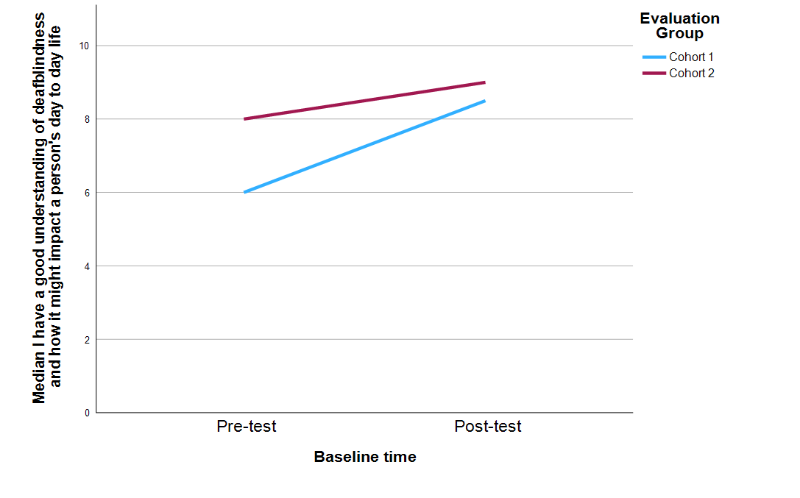
Figure 1 Comparison of pre-and post- test median scores across cohort one and two participants responses for the question “I have a good understanding of deafblindness and how it might impact a person’s day to day life”.

Knowledge of communication
As shown in Figure 2, post-course survey data across both cohorts indicated significantly higher reported levels of knowledge of deafblind communication methods, techniques, and strategies compared to pre-course survey data reports. While there were no statistically significant differences between cohorts in pre-course ratings, Cohort 2 post-course survey participants reported higher levels of knowledge than Cohort 1 post-course survey participants. These findings may indicate that participants in Cohort 1 perceived a greater increase in their knowledge of communication approaches after completion of the course. Cohort 2 possibly had more experience with people with deafblindness prior to commencing the course. See Appendix A for statistical results.
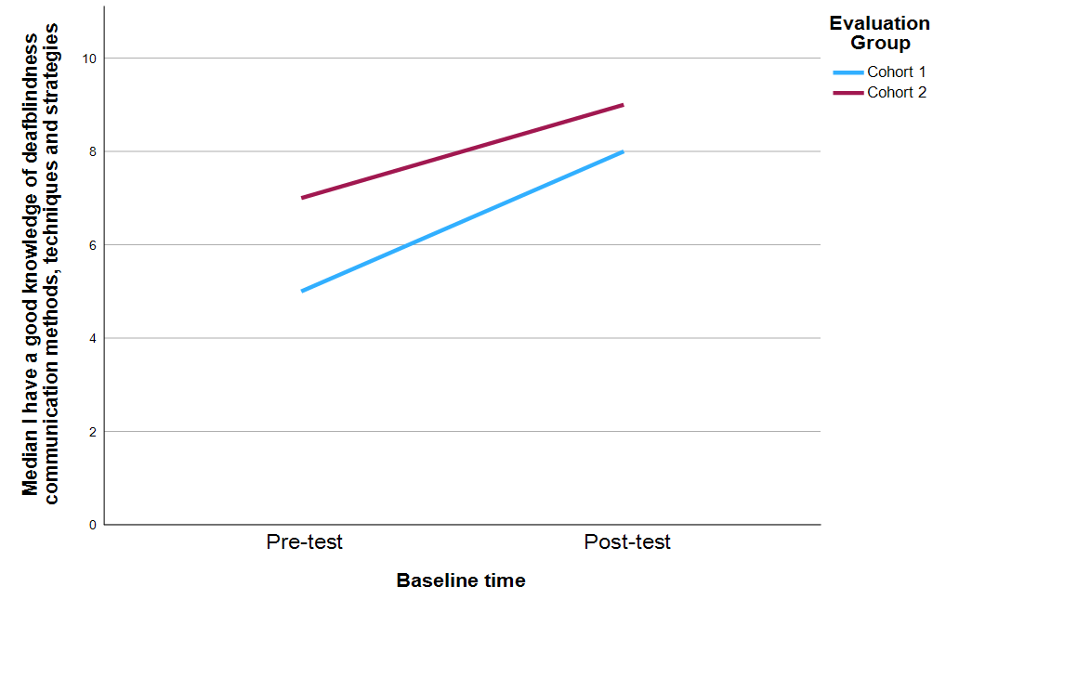
Figure 2 Comparison of pre-and post- test median scores between cohort one and two for the question “I have a good knowledge of deafblindness communication methods, techniques and strategies.

Knowledge of professionals
As shown in Figure 3, participants across both cohorts reported significantly higher post-course survey scores in response to the question about their knowledge regarding the range of professionals who work with people with deafblindness and the roles they perform than pre-course survey scores. As no notable differences between cohorts were evident in self-reported knowledge of professionals either before or after the course, the findings suggest that participants across both cohorts reported similar experienced shifts in their understanding of professional roles. See appendix A for statistical results.

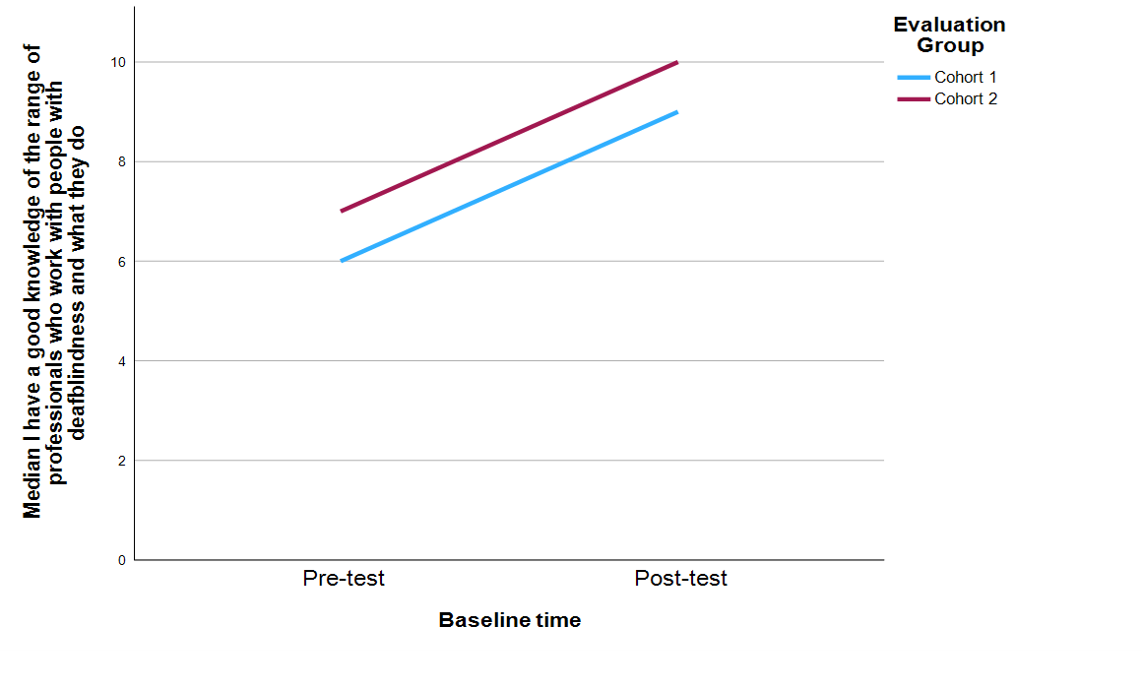

Figure 3 Comparison of pre-and post- test median scores between cohort one and two for the question I have a good knowledge of the range of professionals who work with people with deafblindness and what they do

Overall quantitative findings
Overall, participants across both Cohort 1 and Cohort 2 reported higher ratings in the post-course survey than in the pre-course survey across all three domains. These ratings suggest that participants perceived increased understanding of deafblindness and its impact on everyday life, greater knowledge of communication methods and strategies, and enhanced awareness of the range of professionals who support people with deafblindness.

Module relevance
To explore participant’ perceptions of the relevance of course modules, respondents were asked to rate the extent to which they considered each module relevant on a scale from 0 to 10. As shown in Figure 4, participants across both cohorts generally rated the course as highly relevant to their learning needs. Minor variations in rating were evident for Module 8 as slightly less relevant to Cohort 1 participants, whereas Cohort 2 participants rated the Case Study module slightly lower than Cohort 1 participants. Overall, participants in both cohorts rated the course content as relevant.
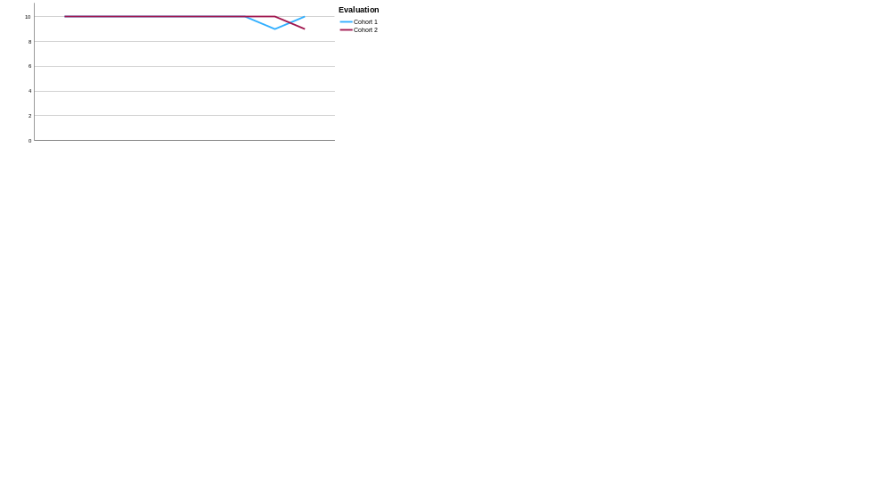
Figure 4 Post-course ratings of module relevance

Module engagement
To explore participants’ perceptions of engagement, respondents were asked to rate the extent to which they found each module engaging on a scale from 0 to 10. As shown in Figure 5, participants across both cohorts reported high levels of engagement across all course modules. These findings suggest that participants generally experienced the course content and learning activities as engaging throughout the program.

Figure 5 Post course ratings of module engagement

Course relevance, accessibility, ease of navigation and likelihood to recommend
Participants were also asked to reflect on their overall experience of the course by responding to the following questions on a scale from 0 to 10:
- To what extent was this course relevant to you and your learning needs?
- To what extent was the course accessible to you?
- How easy was it to use and navigate the online learning platform?
- Would you recommend this course to others?
As shown in Figure 6, participants in both cohorts provided consistently high ratings across all four areas, indicating that the course was perceived as relevant, accessible, and worthwhile. Participants also reported a high likelihood of recommending the course to others. Ratings for ease of use and navigating the online learning platform were slightly lower than ratings for the other questions across both cohorts. While still positive, these responses may suggest that participants experienced some challenges with navigating the platform compared to other aspects of the course.
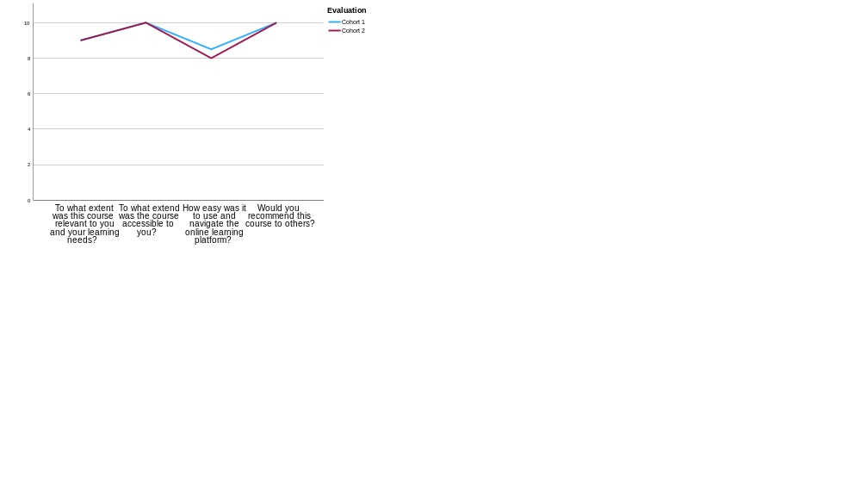
Figure 6 Post-survey ratings of course relevance, accessibility, navigation and referrals

Differences between cohorts
An independent samples t-test identified a significant difference beetween Cohort 1 and Cohort 2 in response to the question, “How many years experience do you have working in deafblindness? “. This finding suggests that participants in the two cohorts entered the course with different levels of professional experience. This difference provides useful context for interpreting variations in participant’s self reported understanding, knowledge, and experience of the course.
Mann-Whitney U tests were conducted to explore differences in survey responses between cohorts. The full results are reported in Appendix A and are presented to provide additional context for the descripive findings discussed in this section.

Key Kirkpatrick Level 4 (Results) Findings
Although it is too early to evaluate the results (real-world outcomes) from applying learning from the course) fully, there are several quantitative results which can be reported. Of the 105 learners who enrolled in the course, more than half completed all modules (N = 70, 60%), submitted the case study (N = 62, 60%) and/or downloaded the certificate (N = 68, 65%).
The number of learners who engaged with the course material, completed all assessment requirements and received their certificate of completion is 68 (pilot cohort, plus cohorts 1 and 2), which is a tangible result, particularly given the significant increase in knowledge reported by participants across both cohorts.
A total of 67% of learners completed all modules, with 59% completing all modules plus the case study assignment. This could be considered favourable when compared with Jordon's (2015) review of completion of 221 Massive Open Online Courses (MOOCs) which was only 0.7% to 52.1% . While not a MOOC, the Deafblind – Introductory Training Course is not dissimilar to a MOOC in its length, assessments and lack of formal accreditation.

Qualitative findings
Thematic analysis of the qualitative data from the post course surveys for cohorts 1and 2 and the interviews were undertaken separately. A deductive approach was taken, using the a priori codes of the Kirkpatrick framework; reaction, learning, behaviour and results. See Appendix B for a summary of themes generated through the analysis. An inductive analysis of participants responses also informed the evaluation. Data from both cohorts and the interviews were analysed separately followed by a presentation of synthesised responses. While the data from both cohorts and the interviews were analysed separately, there was a degree of overlap between the themes generated. While data is presented together, the findings should be read with caution given the differences in years of experience working in deafblindness reported amongst participant cohorts. Tey themes with example quotes for each theme from the data are presented below.

Level 1. Reaction
Two key themes emerged from analysis of participants ‘reaction’ to the DB-ITC; overall favourability, and reaction to the learning design, with each of these having several further subthemes which are outlined below.
Overall, many participants across both cohorts described the course favourably. A gap in learning and development support for families and professionals supporting persons with deafblindness was reported by both professionals and persons with deafblindness participating in the evaluation. The participants described aspects of the course they perceived to increased their confidence in understanding deafblindness and they expressed satisfaction with the availability of online, self-paced delivery, multimodal design and accessibility features, such as the inclusion of Auslan interpreters. Key aspects of the course design that were described to support their engagement included peer-learning opportunities (i.e., through use of the discussion board) and ‘in person’ interactive activities.
Participants reported high levels of satisfaction with the course, and subthemes of relevance – a much-needed course and engagement – learning design features emerged from the data analysis.

Relevance – a much-needed course
Many participants highlighted the relevance of the course, and suggested that existing courses did not adequately cater to the needs of community service providers. Participants with varying degrees of experience also noted that the course was relevant for learning new knowledge and consolidating existing knowledge. This indicates a gap in current training and professional development opportunities.
I have never worked in the deafblind space - everything was new and thus relevant to someone going into this space. (Unknown profession, Cohort 1, R 7)
It consolidated things for me and refreshed my mind, which in turn refreshed my approach in some areas. It reminded that I have learnt so much yet I still have so much to learn. (Unknown Profession, Cohort 1, R 22)
Many participants, including people with deafblindness and public sector employees, highlighted the value of the course:
“Thank you so much! I would like to continue building on this knowledge with more training courses if they become available.” (New teacher of deafblind students, Cohort a1, R5)
and
[The course] “has ignited in me the desire to encourage some colleagues to also learn more about this unique area of 'deaf education… a Deafblind course is a great initiative ‘” (‘Teacher of the Deaf’, Cohort 1, R 9)
In addition, participants highlighted the need for a course tailored to support understanding of the unique experience of deafblindness.
“I sincerely hope this continues onto a full course with a huge uptake, it's certainly needed” (Orientation and Mobility practitioner, Cohort 1, R6)
“[I am] much more across all of the things to be aware of when working in Db” love knowing the DB Info website has all those webinars and an abundance of resources” (Vision Occupational Therapist, Cohort 2, R16)
One participant with deafblindness expressed that a course such as this had been sought by the deafblind community for a long time:
“This [course] is something that… our community have wanted this for a long, long time. We want people who can do these courses and gain some, information and gain some learnings from it to be able to come and work in our community… Really valuable.” (Project Officer, Interview, P7).
In summary, the course was described as a much-needed resource, and relevant to practitioners across the public sector including, but not limited to, disability services, allied health and education. Participants’ responses suggested that the course was relevant to both experienced and new practitioners working with people who are deafblind.

Engagement – learning design features
Participants described aspects of the learning design that supported their engagement including the delivery modality, accessibility features and multi-modal design and variety of activities.
Some participants reported feelings of comfort, reduced overwhelm and immersion during the course.
“I feel less overwhelmed when thinking about some of my very complex clients with DB... [I liked the] Online offering, wealth of expertise and lived experience of online learners, really loved the comprehensive nature of the course and all the topics. I really feel immersed… I love knowing the DB Info website has all those webinars and an abundance of resources " (Occupational Therapist, Cohort 2, R16)
Other aspects of the course that were described as favourable for engagement included hearing from persons with deafblindness, interacting with people through discussion boards, the videos, and the way the course was presented. For example, one participant noted:
“Content presentation- thought that it was great to have content presented in a number of different way- video, transcript and additional written content. Was a great way to keep engagement” (Unknown professional, Cohort 1, R35)
Many participants also described the peer-to-peer learning aspects of the course favourably in terms of engagement. For example:
“I also like the Active Learning modals, which gave me options to suit my learning styles. Interacting and peer-learning from the other students with their varied knowledge and experience. Learnt about other Disability and Deafblind organisations. The services and supports and programs they provide. Learnt from the other students (peer-learning)” (Someone with lived experience of deafblindness" Cohort 2, R12)

Learning Design
Participants expressed satisfaction with several aspects of the learning design including its online delivery, accessibility features, multimodal design, variety of learning activities and the practical nature of the case study.
Participants identified several specific factors that contributed positively to their experience, including the presence of Auslan interpreters, the practical nature of the course and case study, and supporting resources such as the Deafblind Information Australia website.

Self-paced and on-demand
Participants expressed satisfaction with the course's online delivery and the flexibility to complete it at their preferred pace and in their own time. As one participant noted:
"I liked that I could complete it on my own time at my own pace" (Cohort 1, R7).

Accessibility features
Many participants expressed satisfaction with the course's accessibility features, including downloadable audiovisual transcripts, closed captions, interpreters and playback-speed controls.
"It was a comprehensible and easily accessible course for those looking to understand deafblindness" (Cohort 1, R16).

Multimodal design and variety of activities
Participants expressed satisfaction with the multimodal course design, the responsiveness of course facilitators, and the flexibility of assessment tasks. Participants also reported enjoying the learning activities, including quizzes and discussion-board activities.
Many participants described the case study positively. One participant stated:
"I actually loved the case study. Having an opportunity to combine all learnings into one thing was very interesting." (Cohort 1, R 29)

Participant feedback on areas for Improvement
Participants described aspects of the course that they considered could be strengthened or improved. Key themes relating to improvement suggestions related to aspects of the course design, activity design, transfer of learning to the workplace and assessment design.

Course design
Participants reported issues and difficulties relating to the accessibility of the Learning Management System, the learning sequence, and the course being available only online.
Some participants described challenges with the accessibility of the online learning platform. These included the formatting of the discussion board, compatibility with personal software and hardware, the time required to identify workarounds using assistive technologies, and the availability of education support. For example, one participant who described themselves as “Deafblind” reported that accessibility issues with the platform contributed to their decision to discontinue the course:
“"I actually decided to pull out roundabout then because the issues I had were in terms initially, at least in terms of accessibility, trying to use a screen reader and just the time required to understand how to make it work... as it was at the time, battle the platform. Part of the issue there was, because I can't see what's going on, I didn't necessarily know exactly what tricks to try with the screen reader, to get the information out... Probably would have been able to do a bit better if I had a support worker next to me... It just means that accessibility is a very difficult thing to achieve, particularly if you if you try and do it after you've implemented the platform... [while] you could say you're WCAG 3 compatible that doesn't necessarily mean it's accessible to me or to the next person." (Cohort 2, Interviewee 8)
Some participants described difficulties with the learning sequence and the order in which modules were presented, and suggested that information be broken into smaller sections with more scaffolding.
“I felt that some of the information was out of order, not in proper learning sequence” (Educator, Cohort 1, R1)
One participant who described themselves as “a person with profound hearing loss” reported that the format in which information was presented made information difficult to retain.
“Majority of information was presented in lengthy statements. Typical academic need. Information is hard to retain in this format - better scaffolding needed” (Unknown profession, Cohort 1, R27)
Other participants described aspects of the training that they found challenging in an online-only delivery format.
Many participants suggested providing opportunities for participants to meet online for discussion and connection:
“As much as I appreciated being able to work through the course at my own pace and at times that suited me, I wondered about an opportunity for all of the people enrolled to meet via teams for a discussion around 1 of the topics, just to add in some connection beyond the chat room tasks.” (School leader, Cohort 1, R8).

Activity design
Some participants reported challenges with aspects of the activity design. Many participants described dissatisfaction with the audio-visual materials, including their length, repetition, currency, and inconsistencies with the audio-visual and supporting materials.
“Re the pre-recorded videos - personally, these are not very engaging and can be accessed already via the Deafblind Information website. If possible… more 'facing the screen' videos with more 'real' examples.” (Teacher of the Deaf, Cohort 1, R9)
Another participant suggested including contextual information within the module content:
“Some videos need updating if the course goes to accreditation level. It would also be good to have more content in the communication module demonstrating or explains more on how, when, where and why other forms of adapted communication methods are used and by who.” (CommGuide, Cohort 1, R22)

Transfer of learning in the workplace
Participants reported challenges associated with transferring learning to the workplace, including limited opportunities to apply learning, the role of reflective practice, and broader workplace context and process requirements.
Many participants reported that they had not yet had sufficient time to implement the knowledge and skills gained through the course, as little time had elapsed between course completion and data collection.
“I have not yet but I am expected to as I have some clients that are either blind or deaf, and I feel the strategies can be beneficial for them” (Unknown profession, Cohort 2, R8)
One participant reflected on the importance of reflection and ongoing professional development within the workplace, including workplace structures and processes:
“I had a real 'a-ha' moment around hand-under-hand. Working with diverse learners who use many different forms of AAC for many years, it's really made me re-think interactions and opportunities for learning, as well as considerations around 'consent' and the capacity to reject interactions. I've always been mindful of doing 'with' and not 'to', but following this course I feel I need to reflect on my interactions, and do more team reflection too... whether I've implemented any new knowledge or skills from the course, the answer is not yet! But I am eagerly waiting to engage with our two deafblind students starting next year. As a school leader, my role will be more around supporting the structures, resources, curriculum offerings and professional development, but there will be opportunity for me to also work with the boys and help the teaching staff model best practice.” (School leader, Cohort 1, R8)
Another participant suggested the inclusion of additional content relating to connection and peer support:
“Information about the power of connection and peer support for deafblind people. Connection and relationships are critical to a good life and often assist people to overcome a lot of their barriers without professional intervention.” (Unknown profession, Cohort 2, R9)
Another participant referred to the potential value of training for support workers and professionals:
“Support workers and professionals do not receive any tangible financial benefit to doing accredited DB training, other than the knowledge that they have the knowledge and skills to provide a better service to the Deafblind person” (Unknown profession, Cohort 2, R7).

Assessment design
Participants described concerns, challenges and areas they perceived as less effective including inclusivity of assessment options and opportunities for interactivity.
Some participants described the case study assessment as challenging and referred to the need for greater clarity of assessment expectations, additional opportunities for creativity and interactivity, and challenges relating to technical navigation and accuracy of information contained in the course quizzes. One participant reported being “unsure on how to start a case study” (Unknown Profession, Cohort 1, R24).
Participants also made a range of suggestions regarding future delivery and development of the assessment components. Some participants suggested changes to assessment options, including opportunities for creativity and additional teaching and learning support:
“I really struggle with likert scales…I think a couple more case studies with clearer directions. Ie: one where you need to create an individual communication guide etc.” (Unknown Profession, Cohort 1, R29)
Participants also suggested increased opportunities for assessment support and interaction with course facilitators:
“More 1:1 sessions available for course participants to meet them [course facilitators] on Zoom with Auslan interpreters provided by the training team so Deaf people can ask them questions in Auslan about their assessments and clarify any difficult or unfamiliar concepts or facts if needed” (Community Language Aide, Cohort 2, R4).

Level 2. Learning
Key themes generated from the data relating to Kirkpatrick's framework level 2. 'learning' were; knowledge and skills and; learning from specific modules,

Knowledge and skills
Participants described the knowledge, skills and confidence they developed through the course. They described how they learnt about practical communication techniques, the different ways in which people present with deafblindness, supporting people who are deafblind, the deafblind alphabet, and knowledge surrounding the ways to support people to orient themselves within their environment.
For example, one participant described what they learnt:
“The difference between congenital and acquired DB, the wide and varying presentations of DB, many practical ways to support the independence of, work with, communicate with and teach people with DB. Generally, a greater confidence in my own knowledge around DB.” (Unknown, Cohort 1, R34)
Many participants described how the course facilitated the consolidation of existing knowledge developed through lived experience, related work and study, and a recent deafblind information workshop. One highly experienced practitioner described how the course complemented their existing qualifications and experience as a Community Language Aide:
"Yes, [I have developed knowledge and skills from this course]. I still work as a NAATI Community Language Aide specialising in both Auslan and Tactile Auslan (having passed the NAATI accreditation (test of my Auslan fluency skills)), so this course will strengthen my memory and comprehension of technical deafblind work skills." (Community Language Aide, Cohort 2, R4)

Learning from specific modules
Participants described examples of the development of their knowledge, skills and confidence as being facilitated by the learning content in the modules, in particular Module 1: Understanding deafblindness, Module 3: Communication and Module 4: Orientation and Mobility.
A few participants described the value of the Orientation and Mobility module in further developing their knowledge:
“Module 4 [Orientation and Mobility], I entered this course with a lot of previous experience in Deaf and Blind circles individually, along with my own research, this module [is] where I learnt the most new information.” (Cohort 1, R16)
Participants across all data sets described examples of how their confidence in their knowledge of communicating with people who are deafblind increased. This was suggested to be facilitated by learning practical skills throughout the course, such as hand-under-hand techniques.
Many participants identified learning about communication with people who are deafblind as one of the most valuable aspects of the course. Their comments reflected positive attitudes towards the course and highlighted the practical value of the increased understanding, knowledge and skills they learnt. For example, one participant who described the value of applying what they learned in the course through the case study activity noted what they had learnt from the course:
"Understanding the gamut of communication techniques, feeling more comfortable regarding communication for those who are deaf and hard of hearing, understanding the specific roles of teams supporting people with DB, learning the deafblind alphabet, better understanding the importance of the hand-under-hand technique, and understanding DB-suitable personal safety AT. There are gaps for DB people in services, trained professionals, access to mental health care, DB braille teachers and deafblind consultants in NSW” (DB Practitioner, Cohort 2, R16).
Some participants highlighted their insights about the importance of practice development in the workplace, ongoing team reflection and the need for opportunities for learning:
I had a real 'a-ha' moment around hand-under-hand. Working with diverse learners who use many different forms of AAC for many years, it's really made me re-think interactions and opportunities for learning, as well as considerations around 'consent' and the capacity to reject interactions. I've always been mindful of doing 'with' and not 'to', but following this course I feel I need to reflect on my interactions, and do more team reflection too.” (Teacher, Cohort 1, R 1)
“[I have a] further understanding around deaf blindness and impact on daily life. More knowledge around tactile signing. [I] have developed skills in tactile signing and have practiced with colleagues” (Unknown, Cohort 1, R13)
Overall, the core themes relating to the participants reports of learning were often described in relation to increased understanding of communication techniques and skills associated with supporting a deafblind person to navigate their environment. These learnings were described by some participants to support the consolidation of existing knowledge, as also supported by the content in the modules relating to understanding deafblindness, communication and, orientation and mobility.

Level 3. Behaviour
The learnings that participants developed were described to facilitate changes in behaviour in some participants when given real world opportunities to apply their learning. The application of knowledge was described by participants who had opportunities to reflect on their practice. Participants also described sharing knowledge gained through the course by initiating network opportunities, sharing resources, practicing new skills in the workplace, or with family members.

Applying learning
The application of learning was described by some participants for example, through the use of real-world case study and by updating service plan documents related to related to orientation and mobility. A mother who completed the course described how they applied their learning of communication to be able to communicate and connect with their son who is deafblind and relaying learnings to her team:
“[I have new knowledge on] how to communicate and engage more meaningfully. Being more present using constant touch cues to provide a more meaningful interaction. Slowing down and taking the time to listen, engage and be mindful of how my child might be interpreting what is going on around him. I am actively communicating better with my son and utilising key principles learnt and will be relaying them to my team to enhance my child's life for the better. I am blessed to have been given the opportunity to do this course and am so grateful for what I have learnt and look forward to a brighter future teaching my son and engaging in his world more productively” (Parent of a deafblind child, Cohort 1, R19)
Several participants described applying their learning when opportunities arose in their workplace. For example, one participant used their knowledge to support deafblind awareness activities with school students:
"All of my work so far has been with deafblind adults, but while doing this course I had the opportunity to visit a school and work with children on deafblind awareness, as a young boy had just started at the school. The information relating to young children with deafblindness was incredibly helpful." (Profession unknown, Cohort 2, R7)

Sharing knowledge
The development of new knowledge was also described by a couple of participants to be shared to a wider audience after the course by incorporating the specialised information relating to deafblindness within their own training programs.
One participant, who is deafblind and works in the TAFE sector providing Auslan training described how despite their intimate knowledge of deablindness, was able to develop their knowledge of other presentations of deafblindness and explain that to other people, and incorporate that into their training program:
“I'm able to now understand CHARGE after the course, be able to apply that and be able to explain to other people and families what being deaf and having CHARGE syndrome means. So I've used that. At the same time, as you know, I'm an educator. I'm teaching students here in [City]. And in the past, I would easily be able just to point to the PowerPoint and go through that information about deafblindness. But after actually learning this information, I'm now applying it into my own training here that we deliver in the Auslan program. So I'm giving informed information.” (Auslan educator, Interview participant 4).

Use of resources
Participants described how they had applied their learnings either in employment or daily life settings.
"I am currently writing a Guiding Preference document for people who are human guided and some do's and do not, I have incorporated the hand under hand notes, so many of the db community complain about being handled hence the need for the document. In fact, there is other useful info to advance the content, but it has to be a working doc, easy to read and clear about the persons' guide preferences." (Orientation and Mobility Practitioner, Cohort 1, R6)
While participants described being expected by their workplaces to apply their learning, not all had the opportunity to do so.
Other participants showed how they had not yet applied their learnings. For example:
“I’ve not yet had the chance to use what I’ve taken in from this course, however I look forward to being able to.” (Unknown, Cohort 1, R12)
There was a clear expectation from one participant that their workplace expected them to be able to apply their new skills, knowledge and attitude when back on the job:
"Not yet. I am expected to, as I have some clients who are either blind or deaf, and I feel the strategies can be beneficial for them." (Cohort 2, R8)

Level 4. Results
Results from the course are more commonly referred to as return on expectations, which individuals completing the course and workplaces will likely want to see from the course.
Given the short time frame between course completion and evaluation survey completion, insufficient time was available to determine if the learning, and application of learning (change in behaviours) would result in real world results for service recipients or family members with deafblindness.
Future evaluation models that explore workplace or individual expectations prior to the course could support the gathering of evidence to investigate desired outcomes. Likewise, post-course explorations could support this understanding. The impact on individual outcomes for deafblind people could also be explored by seeking input from people who are being supported by course participants.
Some participants accounts suggest that they have applied their learning in their workplace due to the course while others have not. Further exploration including specific examples of applications of learning, in what contexts and any barriers people might encounter could provide more insight, especially with respect to the need for changes in or the development of organisational policies and practices that would support the transfer of new learning into everyday practice and subsequently outcomes for clients.
Additional interview questions
As well as questions addressing the levels in the Kirkpatrick framework, participants who were interviewed were asked some additional questions and the results from data generated by these questions are presented here;
Accreditation
Participants were asked if it would make a difference to them if the course was accredited. There were mixed responses with five participants saying the course being accredited would make no difference to them personally, and three saying it is important that the course is accredited, though more from a systemic, than an individual perspective. Of those who said the course being accredited would make no difference to them personally, some noted that it may benefit others, or may benefit them in the future. Quotes demonstrating thoughts regarding benefits of accreditation to self, others and the sector included:
“For other people, I guess it's it shows people that they've done it like it's I guess for other people, It provides the impetus for will I do it or won't I do it? But oh, this is an accredited course and it's good for perhaps their job prospects in the future.” (Cohort 1, Interviewee 1)
“So having like a formal, if the course were accredited, having that formal accreditation, then that shows people to the world, that shows to the world that I have this formal learning and it's recognized. So I'm seen as someone as knowledge or authority.” (Cohort 2, Interviewee 4)
“…people who work with deafblind, we want to retain people, we want to retain our comm guides, and we want to retain people who work in this area. And you give them a course that is then accredited. More likely to, in my opinion, to sort of want to continue in that journey.” (Cohort 1, Interviewee 7)
“Well, we definitely need an accredited course in deafblindness and in a number of other areas in regard to deafblindness” (Cohort 2, Interviewee 8)
Who would benefit from doing the course?
When asked who would benefit from doing the course, participants reported a broad and diverse range of potential learners including healthcare and allied health professionals, educators, support workers / communication guides, people with deafblindness, family members, first responders, and as broad as ‘any industry, anywhere’. This breadth and diversity is evidenced in these quotes:
“Anyone,…learning about deafblindness, they're teaching that module, then they want to become a support worker to work with deafblind people or comm guides. For example, I think they should do the course, people who are working with deafblind people, to get a formal training, formal understanding, and they'd be able to buy them in the workplace at Deaf Connects or Census or wherever they may be working on their own business. So I think that's one targeted group. What about teachers? Teachers, people, you know, police, first responders, police, fire, ambulance, those that are providing services in the frontline. families that have a person that is deafblind.” (Cohort 2, Interviewee 8)
“To educate people who are going to work with people who are Deafblind and students, I feel family members would also benefit from this course. From reading the introductions, I could also see that Deafblind participants were also interested in doing this online training course.” (Cohort 2, Interviewee 9)

Discussion
The course evaluation through analysis of both quantitative and qualitative feedback from learners, highlights some strengths which other course developers could learn from, as well as areas for improvement. While participants indicated some aspects of the course which they felt needed improvement, overall there was a very high level of satisfaction with the course, and participants from both cohorts consistently rated their knowledge on a range of topics related to deafblindness higher after completing the course. The data indicates a clear need for a course in deafblindness, though an online course alone is likely insufficient to achieve positive changes in service delivery to ultimately improve outcomes for individuals with deafblindness.
In terms of the research questions which shaped this evaluation, question 1 is addressed in the section below on the need for a course on deafblindness. Research question two is addressed in the section below on getting results. Research question 3 which asked what indicators and outcomes are achieved for program participants as a consequence of participating in the course is addressed throughout the below three sections.

The need for a course on deafblindness
From the diversity of participants and their feedback on the course, the need for an Australian course on deafblindness is evident. Participants indicated the relevance of the course to their work across all modules, and the value of the content and learning activities.
While there are a proliferation of resources on deafblindness, there is currently no other Nationally accessible course with targeted learning activities and assessment tasks in Australia.
There appears to be a gap in the skills and foundational knowledge of industry professionals supporting persons with deafblindness. This course demonstrated that regardless of level of deafblindness experience, the course provided valuable learning opportunities for participants. It is evident that there is a gap in current available courses relating to deafblindness in Australia.
Current accredited courses are delivered within an Auslan framework, however, not all people with deafblindness communicate using Auslan and not all professionals working with people with deafblindness require Auslan competencies. There are also a number of accredited courses delivered in other countries, but these do not address the differences in the Australian context, in particular the NDIS and policy contexts.
In terms of addressing the first research question, the evaluation of the DB-ITC clearly demonstrated that learners perceived an increase in their knowledge about good practice in working with people with deafblindness. This suggests that even in its current form, this course is addressing the learning gap reported above to some degree. The extent to which this knowledge was retained and transferred to the workplace would require longitudinal evaluation within a workplace context.

Learning design
There were a variety of features of the course design which the participants viewed favourably. In particular, that it is self-paced / on demand, and the multimodal, accessible nature of the course. The course design had a focus on accessibility given the diversity of access requirements of the target learners. This multimodal approach gave all learners the opportunity to access the materials in ways that worked best for them e.g., listening in the car, reading the transcripts rather than watching the videos, or using the captions to help process what was being said in videos. This is good learning for others considering course design, recognising that having multiple modes of accessing course content benefits all learners, not just those with stated access needs.
While reactions to the course were generally positive, responses regarding ways the course could be improved highlighted a lack of involvement of a learning design professional in the development of the course. A learning design professional could assist with chunking of information, development of appropriate assessment tasks, and general cohesiveness of the course. They could also support learners with different learning strategies and techniques. While the course has some initial videos to orient learners to the Learning Management System, and different features of the course, there is no guidance regarding learning strategies or techniques. These could be particularly valuable given the diverse backgrounds and previous learning experiences of the learners.
It is notable that cohort 2, responded more negatively than cohort 1 regarding ease of navigation and use of the online platform. Learners with specified access requirements such as Auslan users and screen reader users were not enrolled in cohort 1, as accessibility workarounds were still being developed and finalised. From the responses of cohort 2, it is clear that these workarounds were inadequate. While the Auslan videos were viewed favourably, screen reader users found course navigation particularly challenging and the discussion board, highly valued by some learners, was mostly inaccessible to screen reader users. Work is required by aNewSpring to address the accessibility issues, or finding a Learning Management System with higher Web Content Accessibility Guidelines (WCAG) compliance is another option.

Transfer of learning and behaviour change
There is some indication of behaviour change and application of learning which will likely lead to results. For example, referral to specific professionals after learning about their roles in the course, and development of Individual Communication Handbooks, could certainly result in tangible real-world outcomes for individuals with deafblindness. However, it is also recommended that workplaces of the learners commit to providing ongoing supervision and support to apply learning and to continue to learn, practice and develop skills.
Organisational factors like supervisor support, peer reinforcement, and opportunities to use the learned skills on the job are important for transfer of learning. Further they argue, that while training design directly impacts learning and retention, trainee characteristics and the work environment directly influence whether learned skills are actually transferred back to the job.

Getting results
(Hall et al. 2025) argue that in addition to reviewing the content of professional development programs, the delivery of programs and how they are applied in complex environments (such as in the delivery of supports and services to persons who are deafblind) is required.
The aim of the Deafblind -Introductory Training Course was to develop knowledge and skills of learners to ultimately result in benefits to people with deafblindness. Level 4 of Kirkpatrick’s Framework – Results – considers learners achievement of results, or what happens in the workplace as a consequence of the learners’ application of their training. Certainly, real world results for people with deafblindness, was the focus of the second research question shaping this evaluation.
Given the course is on-line with very limited face to face, real time input, and also how soon surveys and interviews were conducted after the course was completed, achieving real world results was challenging. There is also currently no plan to undertake a follow up survey with participants after a longer interval post course completion.
Deafblindness is a highly specialised field and for service providers to become proficient requires ongoing learning development and opportunities to apply and practice new skills, particularly the range of tactile communication approaches and methods.
It is recommended that it is made more explicit prior to enrolling in the course, and throughout the course, the need for ongoing professional development and in particular practice coaching, and that organisations establish policies and practices to support such activities for those returning from training courses such as this.

Conclusion
This evaluation of the online Deafblind – Introductory Training Course indicated that it is perceived very positively by course participants. All learners regardless of existing pre-course levels of knowledge and experience in deafblindness reported increases in understanding across a range of topics. There is evidence of learners applying this new knowledge and understanding in workplace contexts, however it is too early to assess the real world impacts of these changes in practice.
This course is currently filling a notable gap in development of workplace competency in service delivery to people with deafblindness, however more work is required to optimise learner experience and potential for real world outcomes. Refer also to Appendix C for a summary of participant recommendations for future improvements to the course.

Limitations
The current evaluation focused on course improvements and future evaluations could focus more specifically on Levels 3 and 4 of the Kirkpatrick framework to better understand what workplace behaviours are changing, and what real world results are being achieved as a result of completing this course. This would require a more longitudinal approach, for example surveying participants 6 months and 12 months post course completion.

Recommendations
Level 1: Reaction
Participant reactions indicated that there is a gap in training and professional development opportunities that meet the needs of persons with deafblindness. There is an opportunity to collaborate more broadly with the sector, for example through the Auslan, Interpreting and Translation Qualifications Review. The existing credentialled unit, Communicate with Deafblind people, could also be informed by findings from the DB-ITC evaluation. A link to the review is provided below.
Auslan, Interpreting and Translation Qualifications review
Level 2: Learning
Consider ongoing evaluation activities to support learning and development, including continued engagement of evaluation and instructional design professionals to support overall learner experience and understanding of return on expectations for persons with deafblindess and the communities who support them. A link to the Kirkpatrick Model is provided below.
The Kirkpatrick Model
Level 3: Behaviour
Post-course learning requires on-going reflective practice and workplace supervision (Hall et al. 2025). Exploring specific applications of learning, including contexts, enablers and barriers associated with implementation, could provide insights into how behaviour change is supported in the workplace. There is also a need to make more explicit within the course the importance of ongoing learning, professional development and supervision to optimise transfer of knowledge gained through the course to workplace practice and client outcomes.
For further information about the development and delivery of professional training within a disability services context, see the link below.
How we might best develop and deliver training and professional development in positive behaviour support.
Level 4: Results
To better understand the real-world impact of the course people who are deafblind, a longer period between course completion and post course surveys may be required. As an initial step, a World Café approach could be used to co-design training with people with deafblindness and their family members to ensure training directly addresses workforce needs and their priority concerns. A further example advocating for the inclusion of expert voices in the development of professional development and training is provided in the link below (McVilly et al. 2025).
Using expert voices to determine the key components of positive behaviour support for the development of a national professional development and training curriculum.

References
Australian Government. 2018. “National Training Register.” https://training.gov.au/training/details/PSPLAN010/unitdetails.
Hall, Julia R., Danielle Newton, Keith McVilly, Lisa McKay‐Brown, Brent Hayward, and Mirko Uljarevic. 2025. “How We Might Best Develop and Deliver Training and Professional Development in Positive Behaviour Support: A Systematic Review.” Journal of Policy and Practice in Intellectual Disabilities 22(1):n/a. doi:10.1111/jppi.70002.
Kirkpatrick, James D., and Wendy Kayser Kirkpatrick. 2016. Kirkpatrick’s Four Levels of Training Evaluation. Alexandria, Virginia: Association for Talent Development.
McVilly, Keith, Julia R. Hall, Brent Hayward, Mirko Uljarevic, Lisa McKay‐Brown, and Jeffrey Chan. 2025. “Using Expert Voices to Determine the Key Components of Positive Behaviour Support for the Development of a National Professional Development and Training Curriculum.” Journal of Policy and Practice in Intellectual Disabilities 22(4):n/a. doi:10.1111/jppi.70025.
Public Skills Australia. 2026. “Auslan, Interpreting and Translating Qualification Review (Phase 2).” https://publicskillsaustralia.org.au/projects/auslan-interpreting-and-translating-qualification-review-phase2.
SensesWA. 2026. “About Deafblindness.” https://www.senseswa.com.au/about-deafblindness/.
Wittich, Walter, and Shirley Dumassais. 2026. “The WHO ICF Comprehensive Core Set for Deafblindness: A Narrative Overview of the Development Process.” The British Journal of Visual Impairment 44(2):445–61. doi:10.1177/02646196251320351.
Wittich, Walter, Kenneth Southall, Lindsey Sikora, Donald H. Watanabe, and Jean-Pierre Gagné. 2013. “What’s in a Name: Dual Sensory Impairment or Deafblindness?” The British Journal of Visual Impairment 31(3):198–207. doi:10.1177/0264619613490519.

End of document

Appendices

Appendix A Statistical analysis of quantitative survey data

Understanding life impact
Mann-Whitney tests showed that:
- Cohort 1 understanding life impact question ratings were significantly higher post-test (Mdn = 8.5) than pre-test (Mdn = 6), U = 282, z = -5.157, p = <.001 $r_{mw}$= 0.57. Cohort 2’s understanding life impact question was rated significantly higher post-test (Mdn = 9) than pre-test (Mdn = 8), U = 94.5, z = -3.003, p = 0.003 $r_{mw}$= .46. These results suggest that participants ratings of their understanding of life impact was higher in post-test surveys than the participants reports in the pre-test surveys to a moderate effect.
- Pre-test undestanding life impact question was rated significantly higher by cohort two partcipants (Mdn = 8) than cohort one participants (Mdn = 6), U = 497.5, z = -2.015, p = .044 $r_{mw}$= .23. These results suggest participants in cohort two rated their understaning slightly higher than participants in cohort one in the pre-test, to a small effect.
- Post-test understanding life impact scores showed no sigificant differences between cohort one (Mdn = 8.5) and cohort two (Mdn = 9), U = 185, z = -1.571, p= 0.116 $r_{mw}$= .22. These results suggest that partipants post-test scores across both cohorts were relatively similar.

Knowledge of communication
Mann-Whitney tests showed that:
- To assess differences in self-reported cohort 1’s knowledge of communication question was rated significantly higher post-test (Mdn = 8) than pre-test (Mdn = 5), U = 204.5, z = -5.884, p = <.001 $r_{mw}$= 0.65 .
- cohort 2’s knowledge of communication question was rated significantly higher post-test (Mdn = 9) than pre-test (Mdn = 7), U = 38, z = -4.442, p = <.001 $r_{mw}$= 68.
- the post-test knowledge of communication question was rated significantly higher by cohort two partcipants (Mdn = 9) than cohort two participants (Mdn = 8), U = 135, z = -2.705, p = .007 $r_{mw}$= .39.
- the pre-test knowledge of communication showed no sigificant differences in ratings between cohort one and two.

Knowledge of professionals
Mann-Whitney tests showed:
- that cohort 1’s knowledge of professionals question was rated significantly higher post-test (Mdn = 9) than pre-test (Mdn = 6), U = 262.5, z = -5.333, p = <.001 $r_{mw}$= 0.58.
- that cohort 2’s knowledge of professionals question was rated significantly higher post-test (Mdn = 10) than pre-test (Mdn = 7), U = 56.5, z = -3.989, p = <.001 $r_{mw}$= .61.
- no significant differences in pre-test and post-test scores between the two cohorts for the knowledge of professionals question.

Course relevance, accessibility, ease of navigation and likelihood to recommend
A Mann-Whitney test showed no significant differences in cohort post-test scores across all four questions.

Appendix B Summary of themes
Level 1 - Reaction
  - Favorable
    - Relevance: A much needed course
    - Engagement: Learning design features
      - Self-paced and on demand
      - Accessibility
      - Multimodal design and variety of activities
    - Participant feedback on areas for improvement
      - Course design
      - Activity design
      - Transfer of learning in the workplace
      - Assessment design
Level 2 - Learning
  - Knowledge and skills
  - Learning from specific modules
    - Understanding deafblindness
    - Communication
    - Orientation and mobility
  - Confidence
Level 3 - Behaviour
  - Applying learning
  - Sharing knowledge
  - Use of resources
Level 4 – Results

Appendix C Participants suggestions for course content improvement
Key recommendations for consideration in future course development and review include:
- Improve the positioning and visibility of Auslan interpreters.
- Provide more examples of deafblind people using diverse communication methods.
- Increase opportunities for face-to-face and one-to-one engagement with facilitators or coaches.
- Ensure the online learning platform is WCAG compliant.
- Review audiovisual content, including timing and information delivery.
- Expand content relating to multiple disabilities, dual sensory loss and psychosocial disability.
- Include content that extends beyond professional intervention models.
- Review and refine assessment quizzes.
- Better reflect the heterogeneity of deafblind identity and experience.
- Strengthen the balance between professional and peer perspectives and approaches.
- Coursework and study support services (e.g. participation support officer)
- Review technical aspects of the learning design and the consistency of accessibility features across the course.

