

Braille
Fact Sheet
Braille supports access to information and increased participation of people with vision impairments in the community.
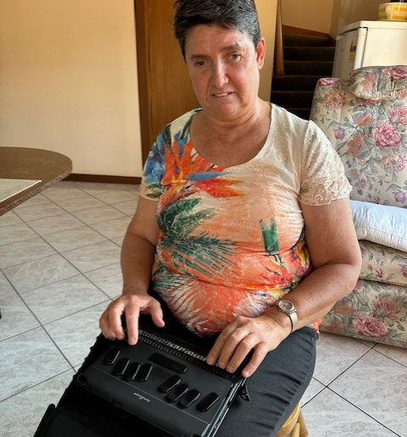

Carleeta
Carleeta learnt braille when she was 29 years old. She now uses braille to read text messages, emails and documents.

What is braille?
Braille is a tactile reading format containing raised dots that are grouped in to symbols which represent letters of the alphabet. A single braille cell contains up to 6 dots, 2 across and 3 vertical, like a box of 6 eggs.

Grade 1 braille
Grade 1 braille is an unabbreviated form of braille which does not contain any short form symbols, commonly called contractions. All words are brailled letter for letter.

Grade 2 braille
Grade 2 braille is an abbreviated form of braille. It contains contractions, which are signs that represent more than one letter within a word, or a whole word when written on its own.

Reading braille
Braille is a tactile reading format which means it is read by touch rather than by sight. Braille is arranged in horizontal lines.
- Have the braille placed at a comfortable distance in front of you, on a firm surface with enough space for you to read.

- Place your fingers on the page, slightly curving them so your fingertips can easily access the braille. Your arms should be at a comfortable level and your wrists should be slightly raised.

- Trace your fingertips from the left margin of the line to where it ends on the right. When you reach the right, trace your fingers back to the left margin and start reading from the next line below.

How to write in braille
In pre-machine times, people used a slate with indents and a stylus to emboss the braille. These are still available today and come in different capacities: 1 line, 4 lines, and even A4 size.
A Braille Labeler can emboss braille on thin adhesive labels. Applying braille labels to belongings assists in item identification.
There are different styles of manual braille machines, similar to old fashioned typewriters. Paper can be fed into the machine, then the braille is embossed by pressing keys which correspond to each braille dot.
There are modern electronic braille devices which offer greater functionality and connectivity. Special manufacturing companies have created a variety of devices for different uses. Some act as a display for a computer or smart phone device. Other devices are stand alone note takers with a full suite of applications like any other computer.
Braille can also be printed using an embosser. These work faster and are used for personal and commercial production. They involve a connectable device such as a computer. The device then sends the information for embossing. After this, the embosser starts printing like any other printer. Braille is embossed on braille grade paper. This is thicker than standard grade paper, so that the dots can maintain their shape and firmness.

Learning and using braille
Organisations providing services to people who are blind may offer braille services. They can help you learn to read and write braille, help you to use braille at home and in the community, may sell braille equipment, have a braille library and also may produce braille materials for you.
Other applications for braille include
- board and card games that have braille symbols enable people with differing levels of vision to play together

- elevators in public buildings will have braille labels on the buttons to assist independent operation

- bathrooms in public places will have braille on the bathroom signs

- some restaurants have braille menus to assist independent ordering

Published: November 2023

