 [insert your logo here]

[Full Name]

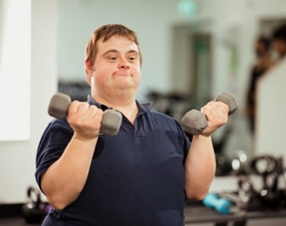

Individual Communication Handbook
[year]

Instructions (Delete after reading)
The communication needs of individuals with deafblindness are often unique and complex.
A unified approach to communicating is needed.
This template may help you develop and structure information about
the communication needs of someone with deafblindness. It is a
guide and not exhaustive. Each person will need something different.
It is recommended you work with a deafblind consultant and a speech
pathologist to guide you through development.
- You do not have to use everything here. Delete what you do not need, including this page after you have read the instructions; and edit, create
and add where needed.
- Cover client image: Move circle to the left, replace & resize client image to fit and move circle back into position. To add the client’s name, use the ‘Replace’ function
- To add images, use the ‘change image’ feature to retain format, and add alternative (alt) text. Alt Text should also be added to tables and links.
- To duplicate pages, copy the body of text and paste at the end of the page break.
- Check accessibility via File/Info/Check for Issues and fix as required.
- On completion and after deleting this page, update the Contents by clicking on the table and selecting ‘Update table’ in the top left.
Contents
Instructions (Delete after reading) 2
Introduction 5
Thank you! 6
[Name] 7
[Name] enjoys… 8
Photos of [Name] 9
Photos of [Name] continued 10
[Name’s] Senses 11
Did you know? 12
Supporting [Name]’s hearing 13
Hearing – compensatory strategies 14
Did you know? 15
Supporting [Name]’s vision 16
Vision – compensatory strategies 17
[enter text & photo] 19
Deafblindness 20
Respectful approach & communication 21
Communicating with [Name] 23
Hand-Under-Hand (HUH) – Why? 26
Hand-Under-Hand (HUH) – How? 27
Hand-Under-Hand method… 28
Hand-Under-Hand Signing – Why? 29
Hand-under-hand Signing – How? 30
Hand-Under-Hand Signing: Videos 31
Hand-Under-Hand Signing 32
On-Body Signing 33
Hand-Under-Hand + Visual Signing 34
Visual Signs 35
Supporting communication and language 36
Examples of expressive communication 37
Object Symbols 39
Object Symbols – [year] 40
Other 43
Suggestions for review 44
Contact 45

Introduction

This resource will…
- introduce you to [Name] and his/her/their interests
- guide you to connect and communicate with him/her/them
- support you to provide him/her/them with opportunities to interact, communicate and learn
- XXX

This resource has been compiled by [name/organisation] in conjunction with…
- XXX
- XXX
[Month, year of update]

Thank you!
The contributions of [Name’s] [insert those who have contributed information eg. family, therapy team, care and education staff] have been integral in developing [Name’s] Communication Handbook.
If you are reading this and spend time
with [Name], you are vital to providing a consistent approach to communicating with them, which will support their
current quality of life, future
development and wellbeing.


[Name]
People who know [Name] have said this about [him/her/them]:
“enter quote”
“enter quote”
“enter quote”

[Name] enjoys…
- List item
- List item
- List item
- List item
- List item

What else have you discovered
that can be added to this list?
- List item
- List item
- List item
- List item
- List item

Photos of [Name]


Photos of [Name] continued

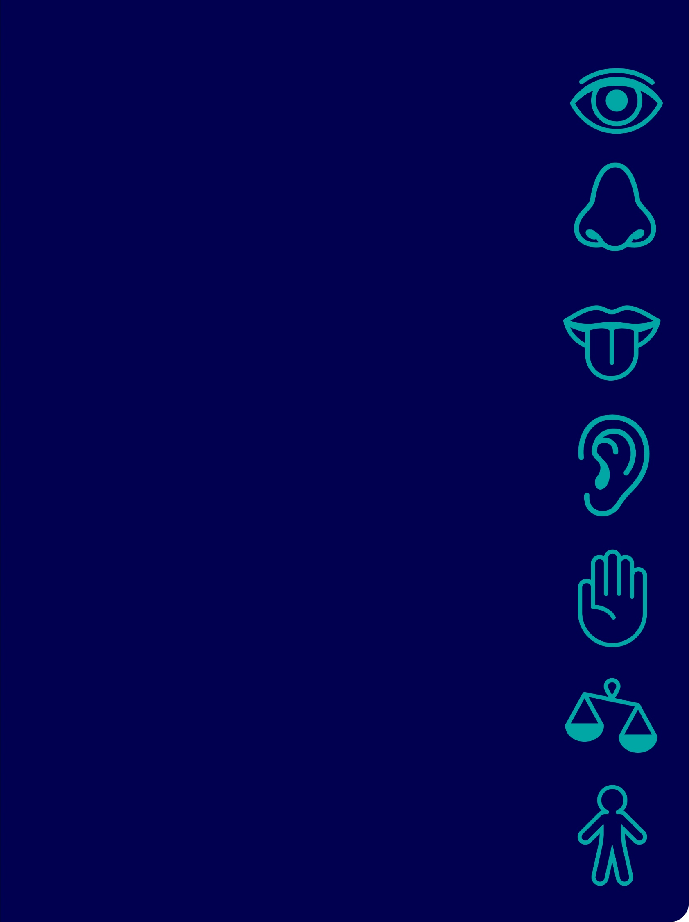
[Name’s]
Senses

Did you know?
[Name’s] hearing level

Impacts these areas of daily life
- X
- x

Other relevant hearing information
- x
- x

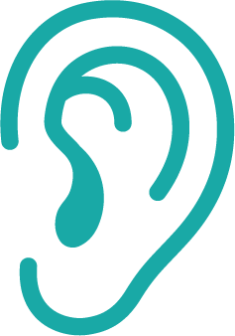

Supporting [Name]’s hearing
[enter text]

Hearing – compensatory strategies
[enter text]

Did you know?
[Name’s] vision level/skills

Impacts these areas of daily life
- x
- x

Other relevant vision information
- x
- x


Supporting [Name]’s vision
[enter text]

Vision – compensatory strategies
[enter text]

Remember…
Use this page when you want to highlight some information

[enter text & photo]
[enter text]
use this page where you need to add more information to a section

Deafblindness

Deafblindness…
- occurs when a combination of hearing and vision skills are affected
- is a unique and isolating sensory disability
- significantly affects communication, learning, interaction, and daily tasks.
- [Name]’s hearing and vision levels and skills indicate deafblindness

Therefore, [Name] has very specific communication and learning needs.
The implications of not meeting these needs include:
- X
- x

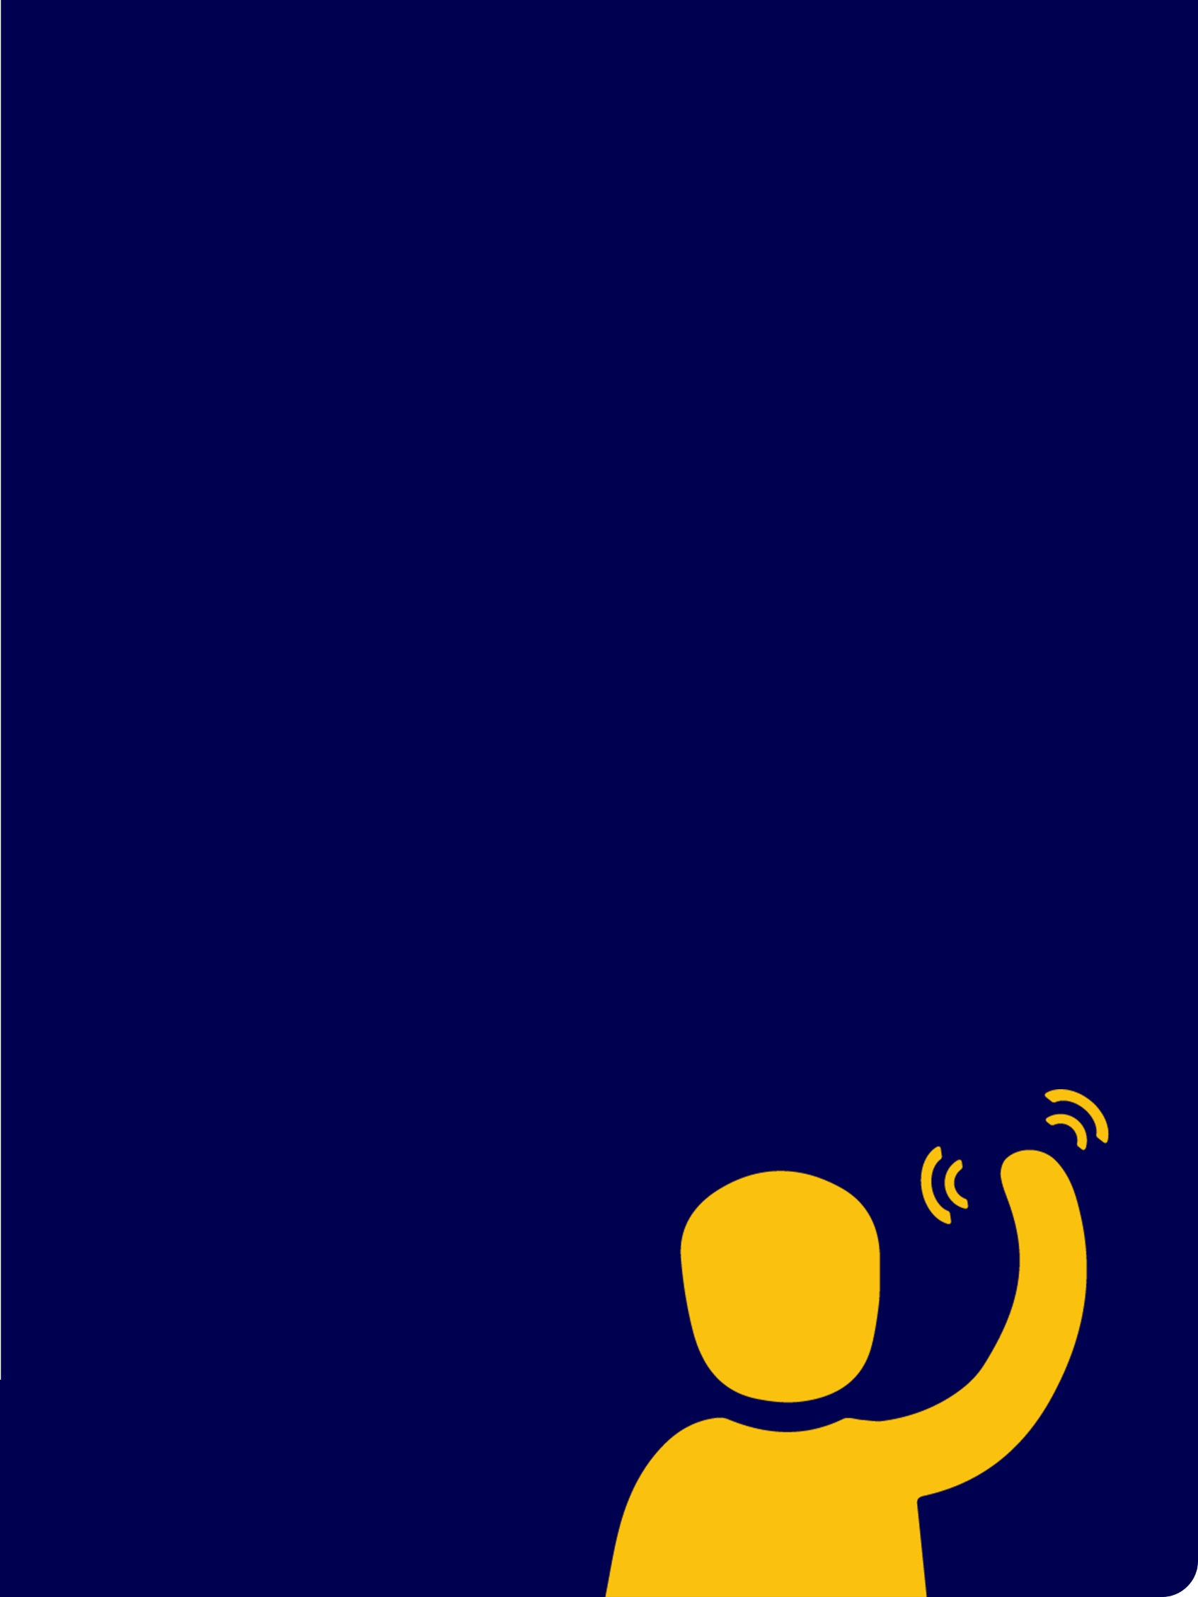
Respectful
approach &
communication

Remember…
Each moment you spend with [Name] is an opportunity for him/her/them to learn something from you and for you to support his/her/their unique communication needs.
Add photos of person interacting/communicating with others

Communicating with [Name]

A brief history.
[enter text]
More information is coming up.

‘S.T.O.P.’
How to approach someone
with deafblindness

Show
…approach from the front.
This provides opportunity to use any functional vision.

Tell
…say their name to get their attention, say your name.
This provides opportunity for use of functional hearing
and to alert them to your presence.

Offer
…should vision/hearing be insufficient to gain attention,
press your hand on their shoulder, upper arm or
back of their hand, to let them know you are there.
Offer your hand / personal signature (under) their hand
to let them know who you are.

Proceed
…with communication, activity, action.

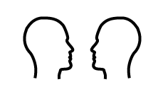
Get face to face
Approach from the front, at eye level.


Greet
[describe usual greeting method]


Prepare
Help prepare for what is about to happen using…
- words
- touch cues
- objects
- signs/gestures


Be aware of light
If possible, position yourself so that a light source
illuminates your face.


Personal signature (unique object/routine/scent)
Present personal signature. This uses senses that
are usually stronger to help confirm who you are.


Departing
Remember to sign “goodbye” when you leave.
This communicates that you have gone (not just in another room)
Use this page to insert/edit tips that support trust, respect & set up for positive communication

Hand-Under-Hand (HUH) – Why?
If you are sighted and hearing,
you watch, listen and copy to learn.
If someone does not have full vision and hearing
it is very difficult to watch and listen to learn
and much information may be missed.

Hand-Under-Hand methods
- help develop curiosity
- help with exploring things, people & surroundings & feel safe about it
- give control over this exploring
- increase independence and discourage dependence
- teach movements including direction, force, speed, rhythm
- help locate important / relevant aspects
- teach how to use an object & complete a task


Hand-Under-Hand (HUH) – How?
- Slide your hand/s under [Name]’s hand/s.
- Their hand/s rest on yours
- Complete the activity as if you were doing it,
at a pace the person can keep up with, allow exploration
- Refrain from picking up their hand or wrist
- This is a skill both will learn together
- Watch some video examples

An example: peeling an apple
- Apple hand - slide your hand under theirs and
move it to the apple & pick it up
- Peeler hand - slide your hand under theirs and
move it to the peeler & pick it up
- Start to peel the apple
- Gradually move your hands, so that they are holding more of the apple and/or more of the peeler and you are holding less of the apple and peeler.
When they understand, they can do it by themselves.


Hand-Under-Hand method…
…to learn how to do it independently
The hand with the pink bracelet is modelling how to…
(Insert photo/s)
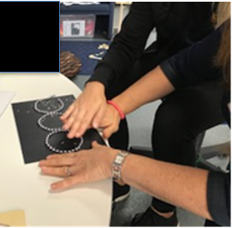
Figure 1 Picture / method description
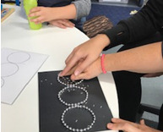
Figure 2 Picture / method description

Hand-Under-Hand Signing – Why?
Hand-Under-Hand signing is a method
of signing to assist feeling the sign:
- The movement, location and hand shape can be felt
- Using sense of touch helps understand, confirm or replace what is not seen or is partially seen
- For those early in their language and communication development or without prior signing knowledge, hand-under-hand
- the proprioceptive and kinaesthetic senses are also used to learn and imitate the sign
- helps develop understanding that communication is a two-way, shared experience.
- helps develop understanding that people take turns when communicating.

List reasons why hand-under-hand
communication is needed
- [enter text]
- [enter text]

Hand-under-hand Signing – How?

List the person specific instructions
- xxx
- xxx

For example
- Describe some of the hand-under-hand signs
- List tips

Hand-Under-Hand Signing: Videos
An internet connection is required to play the
videos in the coming slides. Click the images
to access each online video.

Disclaimer
The contents of these videos are private,
and for training purposes for intended viewers only.
Any use of, interference with, disclosure or copying
of this material is unauthorised and prohibited.

Hand-Under-Hand Signing

‘insert the sign’
Insert video (e.g. that you have put on YouTube)

On-Body Signing

‘insert the sign’
Insert video (e.g. that you have put on YouTube)

Hand-Under-Hand + Visual Signing

‘insert the sign’
Insert video (e.g. that you have put on YouTube)

Visual Signs

‘insert the sign/s’
Insert pictures, photos or video that you have put on YouTube

Supporting communication and language
Strategies to support quality interaction,
communication and language development with [Name]
- List
- List
Currently, [Name] {describe current expressive communication}

Examples of expressive communication
Sign | Communication

Object Symbols

What are object symbols?
Objects can be used to represent a place, person or activity.

Why use them?
Object symbols are particularly useful for supporting [Name]’s communication, given his visual impairment. They help him to understand what will happen next.

How does [Name] use them?
[Insert person specific information & photo of object symbols below, image source Communication Matrix Community Post DIY Tangible object symbols.]
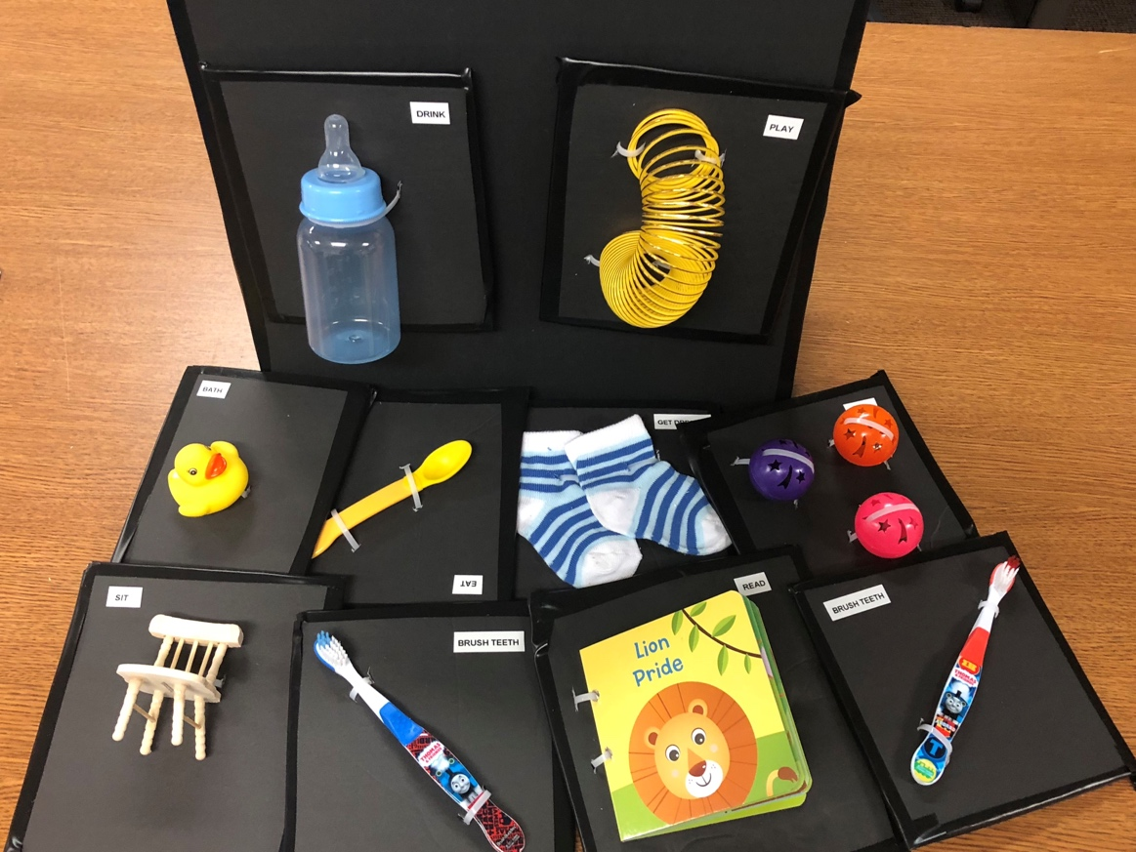

Object Symbols – [year]
[insert photo of object & information to draw attention to]
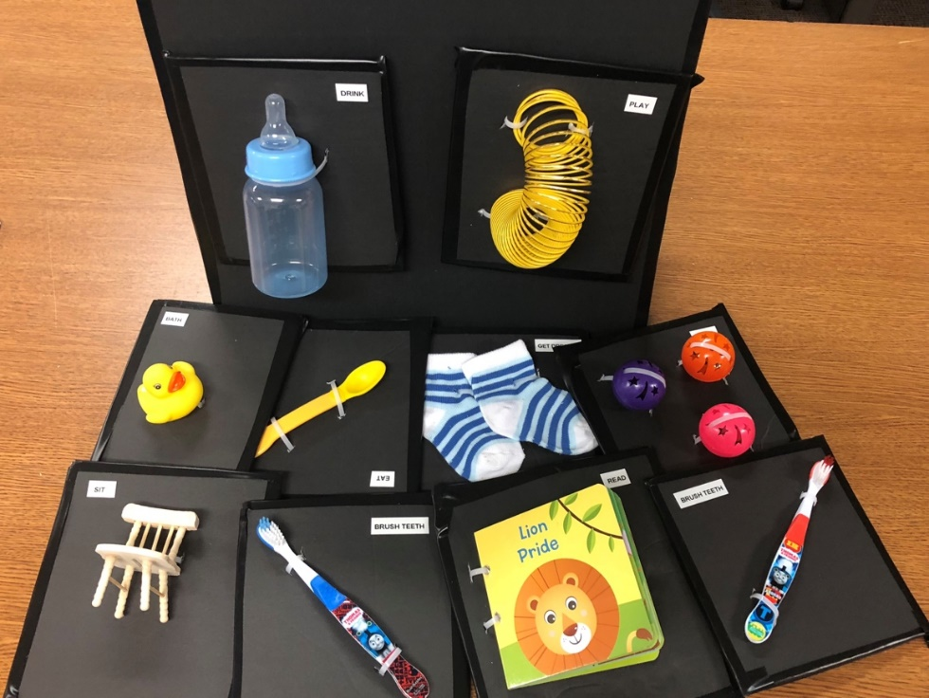
Object | Represents

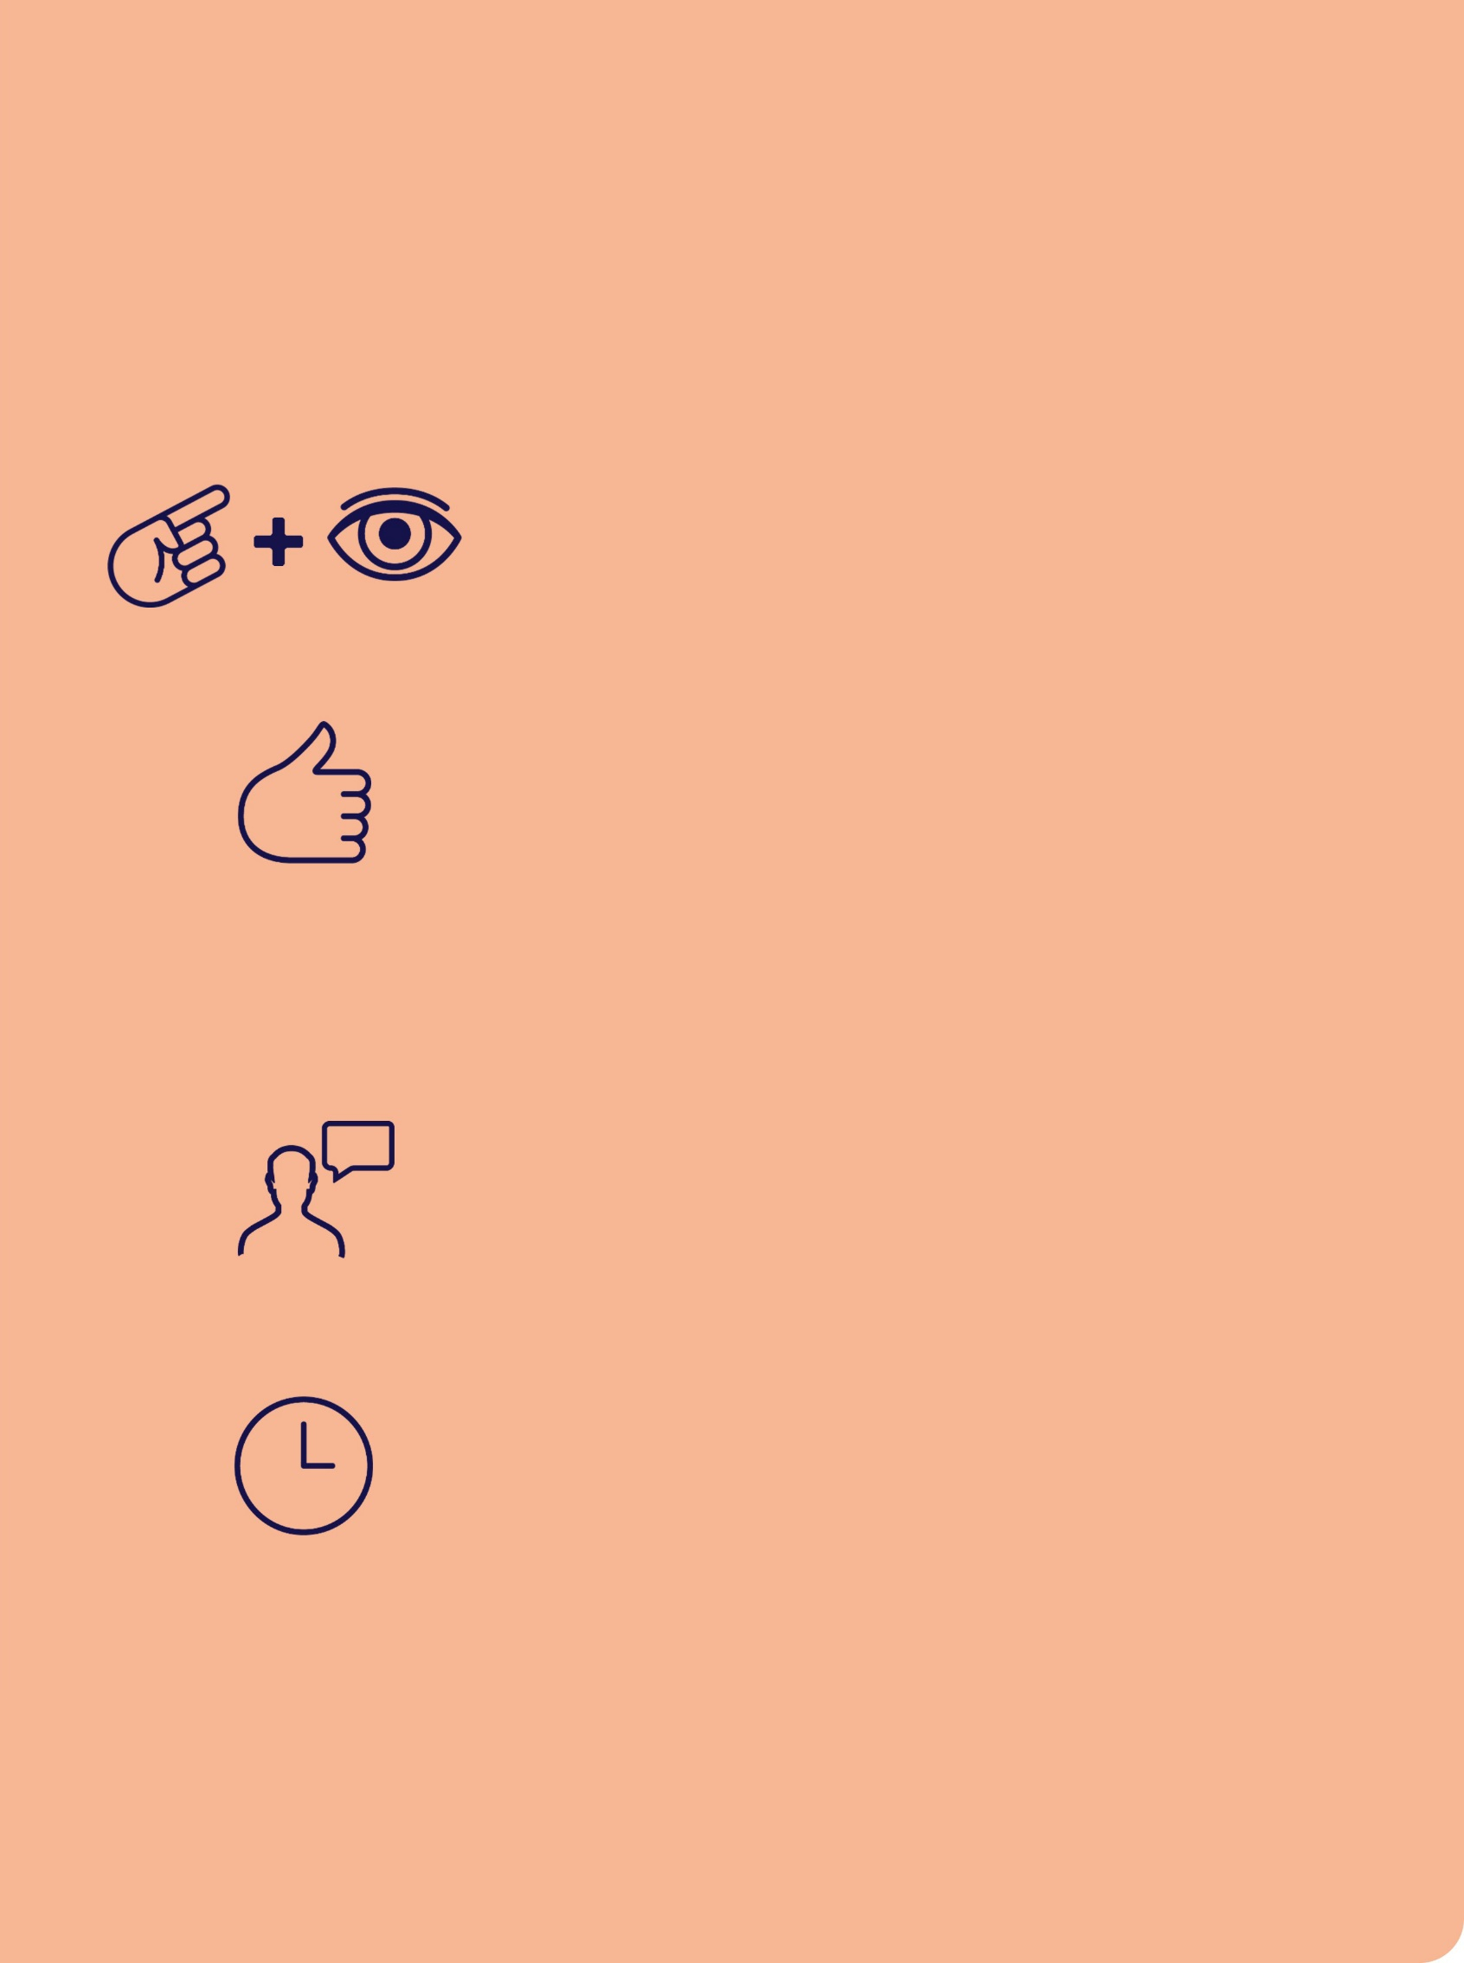
Object Symbols
You can help teach the meaning of these symbols

Present

Show or give item and give time to explore

Sign
Sign what the object represents

+

Say
Say what the activity/person/place is

When?
Just BEFORE the activity begins / person arrives / going to the place and DURING the event

Please Note
This document should be read in conjunction with: (add or delete as required)
- Behaviour Support Plan
- Manual Handing Plan
- Mealtime Management plan
- Orientation & Mobility plan
- Transport plan
- Medication chart

Other
[enter text]

Suggestions for review
This Individual Communication Handbook is a
working document. Please feel free to write any suggestions or updates on this page.
Date | Suggested edit & by whom | Page

Contact
[insert your logo here]
[enter contact details]
For more information about deafblindness go to www.deafblindinformation.org.au

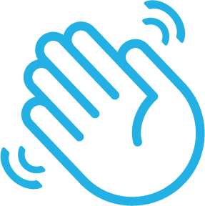
Graphic design and accessibility by
KC & the Graphics Bandwagon


