
Briefing Paper

National Advocacy Priorities for Australians with Deafblindness
Strengthening Disability Reform Through Data, Community Infrastructure, and Workforce Capability
Prepared for: Australian Government policymakers, Members of Parliament, and public sector leaders
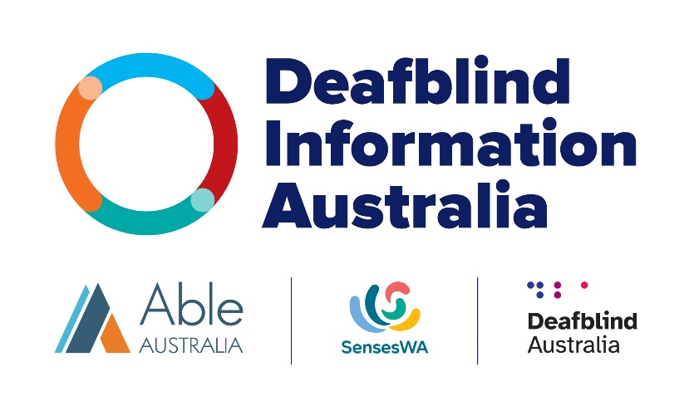
June 2026

Contents
Government Decision Brief 2
Purpose 2
Issue 2
Risks if No Action is Taken 3
Proposed Government Actions 3
Indicative Cost 4
Expected Outcomes 5
Decision 5
Executive Summary 6
Key Messages for Decision-Makers 7
1. Introduction 7
2. Economic and Human Impact 8
3. Advocacy Priority One: 9
National Data and Identification Framework 9
4. Advocacy Priority Two: 10
Sustainable Funding for Deafblind-Led Peer Support and Information Hubs 10
5. Advocacy Priority Three: 12
Awareness, Training, and Workforce Capability 12
6. Implementation Considerations 13
7. Conclusion: A Strategic Opportunity for Government 13

Government Decision Brief
Strengthening System Outcomes for Australians with Deafblindness

Purpose
To highlight a systemic policy gap affecting Australians with deafblindness and seek government support for targeted actions that improve outcomes across disability, health, aged-care, and education systems.

Issue
Deafblindness - the combined loss of hearing and vision - significantly affects communication, access to information, mobility, and independence. Approximately 556,000 Australians are estimated to live with deafblindness, though many remain unidentified within national datasets and service systems.
Furthermore, deafblindness is rarely recognised as a distinct disability within national data or service systems. Hearing and vision loss are typically recorded separately across disability, health, education and aged-care sectors.
Deafblindness includes both acquired dual sensory loss and congenital deafblindness, present from birth. Congenital deafblindness requires identification pathways, family support, and workforce responses that differ substantially from those needed for acquired deafblindness.
This creates systemic gaps in:
- evidence-based policy and service planning
- early identification and intervention
- workforce capability across multiple sectors
- safeguarding and risk identification
- community support infrastructure
Because people with deafblindness frequently interact with multiple service systems over their lifetime, these gaps reduce the effectiveness and efficiency of government investment across several portfolios.

Risks if No Action is Taken
Without targeted policy action, governments are likely to face:
- inefficient service delivery across disability, health, and aged-care systems
- avoidable crisis interventions and hospitalisations caused by communication barriers
- missed early identification in education and childhood services
- increased safeguarding risks, including vulnerability to abuse, neglect, and social isolation
- higher long-term care costs and reduced workforce participation

Proposed Government Actions
Three targeted policy measures could address these systemic gaps.

Establish a National Deafblind Data and Identification Framework
- integrate deafblindness identification into the National Disability Data Asset
- align definitions with international disability classification frameworks
- improve data consistency across disability, health, education, and aged-care systems

Provide Sustainable Funding for Deafblind-Led Peer and Information Hubs
- recognise deafblind-led organisations as essential community infrastructure
- support peer support, information access, and system navigation services
- strengthen government engagement with lived-experience organisations

Invest in Workforce Awareness and Capability
- develop national training resources for health, disability, aged-care, and education workforces
- embed deafblind awareness within existing professional development frameworks
- partner with deafblind-led organisations to deliver training

Indicative Cost
These initiatives represent targeted investment within lower Commonwealth policy cost bands.
Initiative | Indicative Cost
National identification and data framework development project  Initial 6-12 month scoping and development phase, including literature reviews, community consultations, and framework drafting, but excludes full-scale national data system implementation. | $150,000 (one-off)
Workforce training  Initial course development and accreditation setup, instructional design, a Learning Management System (LMS) setup, and ongoing delivery costs. | $190,000 over 5 years
Community infrastructure  Staffing and organisational costs to sustain existing deafblind led organisations | $1.8 million per year nationally

Total investment is likely fall within the $2 - 3 million forward estimates band.

Expected Outcomes
Targeted action would:
- improve service coordination across disability, health, aged care, and education
- reduce crisis service demand and long-term care costs
- strengthen safeguarding and risk identification
- improve workforce capability across sectors
- increase independence, participation, and employment opportunities
Importantly, these measures increase the effectiveness of existing government investments rather than requiring large new programs.

Decision
That government consider targeted policy measures to improve national identification, community infrastructure, and workforce capability for Australians with deafblindness.

Executive Summary
Australia’s disability, health, and aged-care reforms aim to improve inclusion, safety, and service effectiveness. However, Australians with deafblindness remain at high risk of being excluded from these reforms due to systemic gaps in data, service infrastructure, and workforce capability.
Deafblindness - the combined loss of hearing and vision - is a distinct disability that significantly affects communication, mobility, safety, and independence. An estimated 560,000 Australians live with deafblindness, though this is likely an underestimate.
Without targeted action, current reforms risk:
- inefficient service delivery
- avoidable long-term costs
- reduced policy effectiveness
- increased vulnerability and isolation
- inequitable outcomes for a large population group
This white paper outlines three practical, cost-effective priorities that will improve policy implementation and deliver measurable public value:
Priority Actions
- Establish a National Data and Identification Framework to support evidence-based policy and service planning.
- Provide sustainable funding for deafblind-led peer and information hubs to strengthen community infrastructure and reduce service demand.
- Build workforce awareness and capability across disability, health, aged-care, and education systems.
These priorities represent modest investment with significant returns through improved service efficiency, reduced long-term expenditure, and stronger reform outcomes.

Key Messages for Decision-Makers
- Deafblindness is a distinct disability requiring specialised policy responses.
- Current service systems do not reliably identify or support deafblind Australians.
- Strategic investment will reduce long-term costs and increase reform effectiveness.
- Community-led organisations that provide essential infrastructure are currently at risk.
- Workforce capability gaps create systemic service failure and vulnerability risks.
- Action aligns directly with national disability reform objectives and safeguarding priorities.

1. Introduction

What is Deafblindness?
Deafblindness is a unique sensory disability resulting from combined hearing and vision loss. It significantly affects:
- communication and access to information
- mobility and navigation
- social participation
- employment opportunities
- independence and safety
- transition across all life stages
People with deafblindness use diverse communication methods, including spoken language, tactile communication, Australian Sign Language (Auslan) and alternative forms of communication. Needs vary widely depending on onset, severity, and individual circumstances.
Deafblindness is often misunderstood as two separate impairments rather than a single condition with multiplicative impacts. This misunderstanding contributes to policy and service gaps.
Congenital deafblindness requires recognition, distinct from later-onset sensory loss, with need for early identification, family-centred support, and tailored workforce training.

Scale and Policy Context
Available data suggests approximately 556,000 Australians experience deafblindness. However, prevalence is likely higher due to:
- under-identification in service systems
- limited national data collection
- exclusion of remote communities from major surveys
- inconsistent definitions across sectors
These gaps undermine the effectiveness of major reforms, including the National Disability Insurance Scheme (NDIS), health system reforms, and aged-care transformation.
Addressing deafblindness is therefore not a niche issue — it is a system performance issue.

2. Economic and Human Impact

Economic Impact
Failure to address deafblindness effectively leads to:
- inefficient service use
- duplicated or inappropriate supports
- higher crisis intervention costs
- increased long-term care needs
- lost workforce participation
- increased interpreting and communication costs
- development of systemic trauma and self-advocacy fatigue
Targeted identification, early intervention, and appropriate support reduce long-term government expenditure and improve service efficiency.
Investment in prevention and capability produces measurable public return.

Human Impact
Without appropriate support, people with deafblindness experience:
- extreme social isolation
- barriers to healthcare and information
- increased vulnerability to abuse or neglect
- reduced independence
- exclusion from education and employment
- exclusion from community participation
These outcomes contradict Australia’s commitments to disability inclusion, human rights, and safeguarding.

3. Advocacy Priority One:

National Data and Identification Framework

Policy Problem
Australia currently lacks a national identification framework and coordinated national data collection on people with deafblindness. Many systems record hearing and vision loss separately, failing to recognise the combined disability. Thresholds for identification are set by combining severe/profound severity of both hearing and vision loss, although significant impact occurs at both mild and moderate severity levels in the context of combined loss.
This leads to:
- inaccurate policy design
- ineffective resource allocation
- workforce training gaps
- exclusion from data-driven reform
- exclusion from access to services
With increasing reliance on data-based decision-making and changes to the National Disability Insurance Scheme, this gap creates systemic risk.

Recommended Government Action
Government should establish a national framework to:
- review existing datasets across disability, health, education, and aged care
- recognise deafblindness as a unique disability, separate from hearing and vision loss
- develop national functional definitions aligned with the World Health Organization International Classification of Functioning, Disability and Health, Core Sets for deafblindness
- incorporate deafblind identification into the National Disability Data Asset
- ensure definitions and data collection explicitly recognise congenital and complex presentations of deafblindness and support early childhood identification and intervention pathways
- ensure consistent classification across service systems

Policy Benefits
- evidence-based policy development
- targeted service delivery
- improved workforce planning
- more efficient use of public funding
- improved monitoring of reform outcomes

4. Advocacy Priority Two:

Sustainable Funding for Deafblind-Led Peer Support and Information Hubs

Policy Problem
Deafblind-led community organisations provide essential services that government systems cannot easily replicate, including:
- peer support
- information access
- community connection
- policy feedback
- advocacy informed by lived experience, family and parent-to-parent support, particularly where the person with deafblindness is a child and the family functions as the primary support unit
These organisations currently operate with short-term funding and face ongoing uncertainty.
Generic sensory disability services have not successfully replaced deafblind-specific support due to specialised needs.

Recommended Government Action
Government should:
- provide secure, long-term funding for deafblind-led organisations
- recognise peer support as essential service infrastructure
- strengthen collaboration between government and community organisations
- support national and state-level advocacy networks
- recognise and fund family and parent-led support networks

Policy Benefits
- reduced social isolation and crisis demand
- increased capacity of people with deafblindness and those who support them (including support workers and interpreters) through experiential learning
- lower information and interpreting costs
- improved policy design through community feedback
- stronger reform implementation
- increased community participation and independence
This represents preventative investment that reduces downstream expenditure.

5. Advocacy Priority Three:

Awareness, Training, and Workforce Capability

Policy Problem
The Royal Commission into Violence, Abuse, Neglect and Exploitation of People with Disability identified widespread lack of professional understanding of deafblindness.
Across disability, health, aged-care, and education systems:
- few professionals are trained to assess deafblindness
- services are frequently inappropriate or ineffective
- individuals may receive inadequate or no support
- individuals may receive inappropriate assessment of behaviours or psychiatric issues
This creates systemic risk, including safeguarding concerns.

Recommended Government Action
Government should:
- invest in national training programs for relevant workforces which differentiates levels to target
  - awareness raising,
  - effective needs assessment, and
  - recommendation and provision of support services, including, interpreter, support worker/Comm Guide and allied health support
  - training on complex presentations
  - early intervention for children with congenital deafblindness
- support development of specialist training resources
- targeted training using improved national data
- partner with deafblind-led organisations to deliver training and experiential learning opportunities

Policy Benefits
- improved service quality and effectiveness
- reduced safeguarding risk
- greater independence for individuals
- reduced long-term service costs
- increased workforce capability across sectors
- reduced systematic trauma

6. Implementation Considerations
The three priorities are mutually reinforcing:
- Data and identification enable targeted training and funding decisions.
- Community infrastructure supports effective implementation.
- Workforce capability ensures service quality.
Coordinated implementation will maximise policy impact and cost-effectiveness.

7. Conclusion: A Strategic Opportunity for Government
Australians with deafblindness face preventable barriers created by system gaps rather than individual limitations.
Addressing these gaps will:
- strengthen national disability reform outcomes
- improve service efficiency
- reduce long-term expenditure
- enhance safeguarding
- promote equitable participation
Targeted investment in data, community infrastructure, and workforce capability represents a practical and cost-effective policy response that aligns with national reform priorities.
The opportunity now exists for government leadership to ensure that disability reforms deliver equitable outcomes for all Australians.
Supported by
 |  | 
 | 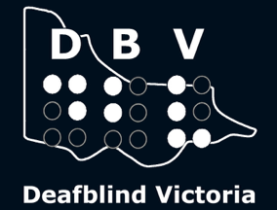 | 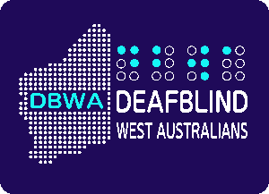
 |  | 
End of document.

