

Deafblind Introductory Training Course
  - Australia’s first online training course aimed at improving knowledge about and support for people with deafblindness.
Location Online self-paced training platform
Duration 20-25 hours learning over six-seven weeks.
Apply by: 8th May 2026 (runs 11th May-29th June 2026)
31st July 2026 (runs 3rd Aug-21st Sept 2026)
30th Oct 2026 (runs 2nd Nov- 21st Dec 2026)
8th Jan 2027 (runs 11th Jan-1st Mar 2027)
Cost Fees are subsidised for 2026-2027.
$400 per place ($300 for valid healthcare, pension, or student card holders). Sponsored places (free to access) are available on application.
Download cost and sponsored place information
Registration Email: Meredith.Prain@senses.org.au
More information Open Deafblind Introductory Training Course webpage
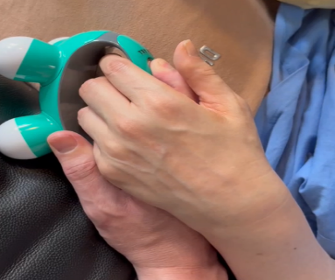
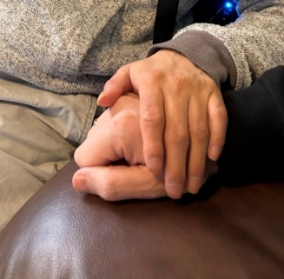
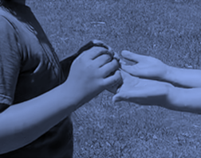

Participants
This online course is suitable for anyone with an interest in
- combined deafness and blindness (deafblindness)
- sensory disability, meaning one or more of the senses are affected
- complex disability
The following people may find this course useful:
- People with deafblindness and their families
- Educators
- Allied health professionals
- Comm guides and Support workers
- Aged care professionals
- Advocates
- Researchers
Course aim and content
This online course aims to equip participants with a broad understanding of the spectrum of deafblindness and key considerations and supports individuals with deafblindness need, to have a good quality of life.
The course is organised over eight learning modules and a case study module, covering:
- Understanding deafblindness
- Accessibility
- Communication
- Orientation and mobility
- Acquired deafblindness
- Congenital deafblindness
- Person-centered support and independence
- Policy and funded support
- Case study module
Download module outcomes
Accessibility: Video content has Auslan interpreting, open captions, and written transcription.
Questions? Contact:
Meredith Prain Meredith.Prain@senses.org.au
Project Manager, Deafblind Information Australia
Senior Speech Pathologist & Deafblind Consultant, SensesWA, Able Australia

End of document.

