

Deafblind Introductory Training Course
  - Australia’s first online training course aimed at improving knowledge about and support for people with deafblindness.
Location Online self-paced training platform
Duration 20-25 hours learning over eight weeks.
Enrolment dates 15 January 2026 (closes 30 March 2026)
Cost Subsidised fees for 2025-2026.
$400 per place ($300 for valid healthcare, pension, or student card holders).
Bulk discounts apply for financial year 2025/26 subject to course intake dates. Buy 10 places at $400 each and then buy more for $320 each.
Sponsored places (free to access) are available on application.
Download cost and sponsored place information (Word docx 422KB)
Registration Email meredith.prain@senses.org.au
More information Open Deafblind Introductory Training Course webpage

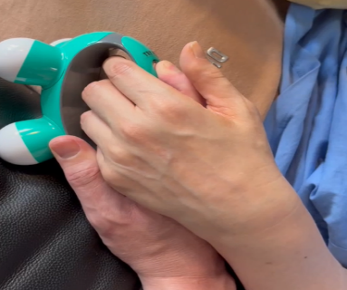



Participants
This online course is suitable for anyone with an interest in learning about people living with dual sensory loss. This includes:
- People with both deafness and blindness,
- People with at least one sensory disability
- People with complex disabilities.

The following people may find this course useful:
- People with deafblindness and their families
- Educators
- Allied health professionals
- Comm guides and Support workers
- Aged care professionals
- Advocates
- Researchers
Course aim and content
This online course aims to equip participants
to understand the spectrum of deafblindness and
understand key considerations and supports people with deafblindness need, to have a good quality of life.
The course has eight learning modules and a case study module, covering:
- Understanding deafblindness
- Accessibility
- Communication
- Orientation and mobility
- Acquired deafblindness
- Congenital deafblindness
- Person-centered support and independence
- Policy and funded support
- Case study module
Download module outcomes (Word docx 445KB)
Accessibility: Video content has Auslan interpreting, open captions, and written transcription.
Application for discretionary/sponsored places
Applicants with family members with deafblindness or who work in the field of deafblindness can apply for a sponsored place.
Applicants to state:
- Name:
- Job role (if relevant)
- Connection to/interest in deafblindness:
- Why you want to do this course:
A short application would be welcomed. Applications are to be emailed to: meredith.prain@senses.org.au

Find out about the next groups
Enrolment deadline: Group 3 15 January 2026 (course runs between Feb and March 2026)

Contact:
Meredith Prain
Project Manager, Deafblind Information Australia
Senior Speech Pathologist & Deafblind Consultant, SensesWA, Able Australia
meredith.prain@senses.org.au

End of document.

