

# Deafblind Introductory Training Course

Australia’s first online training course aimed at improving knowledge about and support for people with deafblindness.

**Location** Online self-paced training platform

**Duration** 20-25 hours learning over three months.

**Enrolment dates** 13 October 2025 (closes 31 December 2025)

5 January 2026 (closes 31 March 2026)

**Cost** Fees are subsidised for 2025-2026.

$400 per place ($300 for valid healthcare, pension, or student card holders).

Sponsored places (free to access) are available on application.

[Download cost and sponsored place information](https://www.deafblindinformation.org.au/wp-content/uploads/2025/09/DB-ITC-Cost-and-sponsored-places-information-branded.docx)

**Registration** Email: [Meredith.Prain@senses.org.au](mailto:Meredith.Prain@senses.org.au)

**More information** [Open Deafblind Introductory Training Course webpage](https://www.deafblindinformation.org.au/about-deafblindness/deafblind-introductory-training-course/)

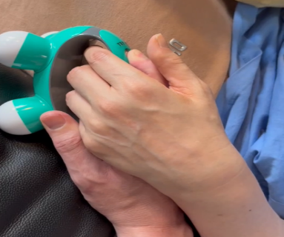

**Participants**

This online course is suitable for anyone with an interest in

* combined deafness and blindness (deafblindness)
* sensory disability, meaning one or more of the senses are affected
* complex disability

The following people may find this course useful:

* People with deafblindness and their families
* Educators
* Allied health professionals
* Comm guides and Support workers
* Aged care professionals
* Advocates
* Researchers

**Course aim and content**

This online course aims to equip participants to have a broad understanding of the spectrum of deafblindness and show an understanding of key considerations and supports individuals with deafblindness need, to have a good quality of life.

The course is organised over eight learning modules and a case study module, covering:

1. Understanding deafblindness
2. Accessibility
3. Communication
4. Orientation and mobility
5. Acquired deafblindness
6. Congenital deafblindness
7. Person-centered support and independence
8. Policy and funded support
9. Case study module

[Download module outcomes](https://www.deafblindinformation.org.au/wp-content/uploads/2025/09/DB-ITC-Outcomes-Summary-v1.docx)

**Accessibility:** Video content has Auslan interpreting, open captions, and written transcription.

**Questions? Contact:**

**Meredith Prain** [Meredith.Prain@senses.org.au](mailto:Meredith.Prain@senses.org.au)

Project Manager, Deafblind Information Australia

Senior Speech Pathologist & Deafblind Consultant, SensesWA, Able Australia

End of document.