 [insert your logo here]

# [Full Name]

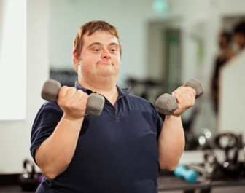Individual Communication Handbook  
[year]

## Instructions (Delete after reading)

The communication needs of individuals with deafblindness are often unique and complex.   
A unified approach to communicating is needed.

This template may help you develop and structure information about   
the communication needs of someone with deafblindness. It is a   
guide and not exhaustive. Each person will need something different.   
It is recommended you work with a deafblind consultant and a speech   
pathologist to guide you through development.

* **You do not have to use everything here.** Delete what you do not need, including this page after you have read the instructions; and edit, create   
  and add where needed.
* Cover client image: Move circle to the left, replace & resize client image to fit and move circle back into position. To add the client’s name, use the ‘Replace’ function
* To add images, use the ‘change image’ feature to retain format, and add alternative (alt) text. Alt Text should also be added to tables and links.
* To duplicate pages, copy the body of text and paste at the end of the page break.
* Check accessibility via File/Info/Check for Issues and fix as required.
* On completion and after deleting this page, update the Contents by clicking on the table and selecting ‘Update table’ in the top left.

Contents

Instructions (Delete after reading) 2

Introduction 5

Thank you! 6

[Name] 7

[Name] enjoys… 8

Photos of [Name] 9

Photos of [Name] continued 10

Did you know? 12

Supporting [Name]’s hearing 13

Hearing – compensatory strategies 14

Did you know? 15

Supporting [Name]’s vision 16

Vision – compensatory strategies 17

[enter text & photo] 19

Deafblindness 20

Communicating with [Name] 23

Hand-Under-Hand (HUH) – Why? 26

Hand-Under-Hand (HUH) – How? 27

Hand-Under-Hand method… 28

Hand-Under-Hand Signing – Why? 29

Hand-under-hand Signing – How? 30

Hand-Under-Hand Signing: Videos 31

Hand-Under-Hand Signing 32

On-Body Signing 33

Hand-Under-Hand + Visual Signing 34

Visual Signs 35

Supporting communication and language 36

Examples of expressive communication 37

Object Symbols 39

Object Symbols – [year] 40

Communication routines 42

Communication routine: Videos 46

Please note 47

Other 48

Suggestions for review 49

Contact 50

## Introduction

### This resource will…

* introduce you to [Name] and his/her/their interests
* guide you to connect and communicate with him/her/them
* support you to provide him/her/them with opportunities to interact, communicate and learn
* XXX

#### This resource has been compiled by [name/organisation] in conjunction with…

* XXX
* XXX

[Month, year of update]

## Thank you!

The contributions of [Name’s] [insert those who have contributed information eg. family, therapy team, care and education staff] have been integral in developing [Name’s] Communication Handbook.

If you are reading this and spend time   
with [Name], you are vital to providing a consistent approach to communicating with them, which will support their   
current quality of life, future   
development and wellbeing.

­

## [Name]

People who know [Name] have said this about [him/her/them]:

“enter quote”

“enter quote”

“enter quote”

## [Name] enjoys…

* List item
* List item
* List item
* List item
* List item

### What else have you discovered that can be added to this list?

* List item
* List item
* List item
* List item
* List item

## Photos of [Name]





## Photos of [Name] continued



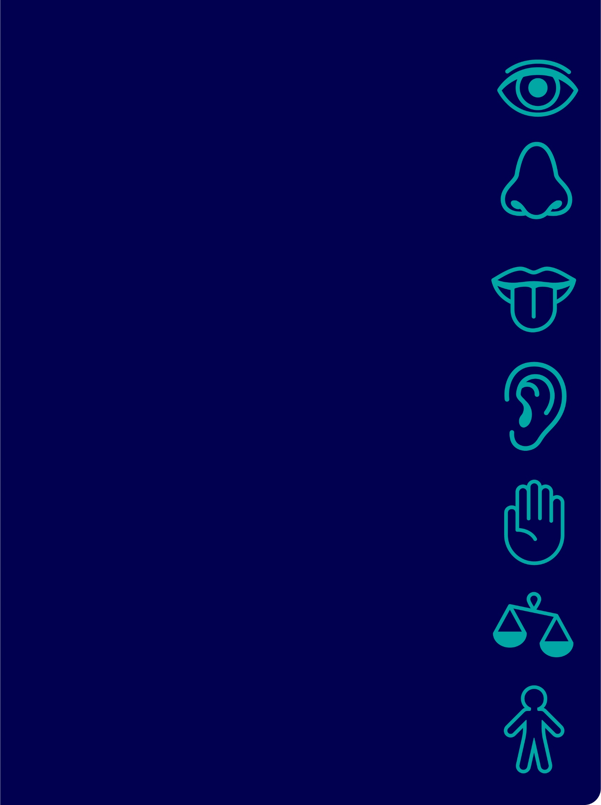­­­[Name’s]   
Senses

## Did you know?

[Name’s] hearing level

### Impacts these areas of daily life

* X
* x

### Other relevant hearing information

* x
* x



## Supporting [Name]’s hearing

[enter text]

## Hearing – compensatory strategies

[enter text]

## Did you know?

[Name’s] vision level/skills

### Impacts these areas of daily life

* x
* x

### Other relevant vision information

* x
* x



## Supporting [Name]’s vision

[enter text]

## Vision – compensatory strategies

[enter text]

Remember…

Use this page when you want to highlight some information

## [enter text & photo]

[enter text]

use this page where you need to add more information to a section



## Deafblindness

### Deafblindness…

* occurs when a combination of hearing and vision skills are affected
* is a unique and isolating sensory disability
* significantly affects communication, learning, interaction, and daily tasks.
* [Name]’s hearing and vision levels and skills indicate deafblindness

#### Therefore, [Name] has very specific communication and learning needs.

The implications of not meeting these needs include:

* X
* x

Respectful  
approach &  
communication

­

Remember…

Each moment you spend with [Name] is an opportunity for him/her/them to learn something from you and for you to support his/her/their unique communication needs.

Add photos of person interacting/communicating with others



## Communicating with [Name]

### A brief history.

[enter text]

More information is coming up.

‘S.T.O.P.’  
How to approach someone   
with deafblindness

Show

**…approach from the front.**   
This provides opportunity to use any functional vision.

Tell

**…say their name to get their attention, say your name.**   
This provides opportunity for use of functional hearing   
and to alert them to your presence.

Offer

**…should vision/hearing be insufficient to gain attention,   
press your hand on their shoulder, upper arm or   
back of their hand, to let them know you are there.**   
Offer your hand / personal signature (**under)** their hand   
to let them know who you are.

Proceed

**…with communication, activity, action.**

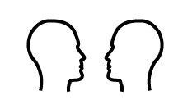Get face to face

Approach from the front, at eye level.

Greet

[describe usual greeting method]

Prepare

Help prepare for what is about to happen using…

* words
* touch cues
* objects
* signs/gestures

Be aware of light

If possible, position yourself so that a light source   
illuminates your face.

Personal signature (unique object/routine/scent)

Present personal signature. This uses senses that   
are usually stronger to help confirm who you are.

Departing

Remember to sign “goodbye” when you leave.   
This communicates that you have gone (not just in another room)

Use this page to insert/edit tips that support trust, respect & set up for positive communication

## Hand-Under-Hand (HUH) – Why?

If you are sighted and hearing,   
you watch, listen and copy to learn.

If someone does not have full vision and hearing   
it is very difficult to watch and listen to learn   
and much information may be missed.

### Hand-Under-Hand methods

* help develop curiosity
* help with exploring things, people & surroundings & feel safe about it
* give control over this exploring
* increase independence and discourage dependence
* teach movements including direction, force, speed, rhythm
* help locate important / relevant aspects
* teach how to use an object & complete a task



## Hand-Under-Hand (HUH) – How?

1. Slide your hand/s under [Name]’s hand/s.
2. Their hand/s rest on yours
3. Complete the activity as if you were doing it,   
   at a pace the person can keep up with, allow exploration
4. Refrain from picking up their hand or wrist
5. This is a skill both will learn together
6. [Watch some video examples](https://www.wsdsonline.org/hand-under-hand/)

### An example: peeling an apple

* Apple hand - slide your hand under theirs and   
  move it to the apple & pick it up
* Peeler hand - slide your hand under theirs and   
  move it to the peeler & pick it up
* Start to peel the apple
* Gradually move your hands, so that they are holding more of the apple and/or more of the peeler and you are holding less of the apple and peeler.   
  When they understand, they can do it by themselves.



## Hand-Under-Hand method…

…to learn how to do it independently

The hand with the pink bracelet is modelling how to…

(Insert photo/s)

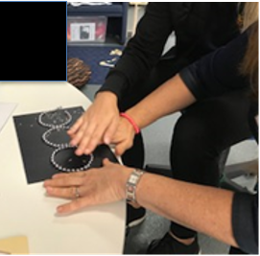

Figure 1 Picture / method description

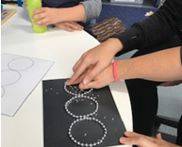

Figure 2 Picture / method description

## Hand-Under-Hand Signing – Why?

Hand-Under-Hand signing is a method   
of signing to assist feeling the sign:

* The movement, location and hand shape can be felt
* Using sense of **touch** helps understand, confirm or replace what is not seen or is partially seen
* For those early in their language and communication development or without prior signing knowledge, hand-under-hand
* the **proprioceptive** and **kinaesthetic** senses are also used to learn and imitate the sign
* helps develop understanding that communication is a **two-way, shared experience**.
* helps develop understanding that people **take turns** when communicating.

### List reasons why hand-under-hand communication is needed

* [enter text]
* [enter text]

## Hand-under-hand Signing – How?

### List the person specific instructions

1. xxx
2. xxx

#### For example

* Describe some of the hand-under-hand signs
* List tips



## Hand-Under-Hand Signing: Videos

An internet connection is required to play the   
videos in the coming slides. Click the images   
to access each online video.

Disclaimer

The contents of these videos are private,   
and for training purposes for intended viewers only.   
Any use of, interference with, disclosure or copying   
of this material is unauthorised and prohibited.

## Hand-Under-Hand Signing

### ‘insert the sign’

Insert video (e.g. that you have put on YouTube)

## On-Body Signing

### ‘insert the sign’

Insert video (e.g. that you have put on YouTube)

## Hand-Under-Hand + Visual Signing

### ‘insert the sign’

Insert video (e.g. that you have put on YouTube)

## Visual Signs

### ‘insert the sign/s’

Insert pictures, photos or video that you have put on YouTube

## Supporting communication and language

Strategies to support quality interaction,   
communication and language development with [Name]

* List
* List

Currently, [Name] {describe current expressive communication}

## Examples of expressive communication

| Sign | Communication |
| --- | --- |
|  |  |
|  |  |
|  |  |
|  |  |
|  |  |
|  |  |
|  |  |
|  |  |
|  |  |
|  |  |
|  |  |
|  |  |
|  |  |

## Object Symbols

What are object symbols?

Objects can be used to represent a place, person or activity.

Why use them?

Object symbols are particularly useful for supporting [Name]’s communication, given his visual impairment. They help him to understand what will happen next.

How does [Name] use them?

[Insert person specific information & photo of object symbols below, image source [Communication Matrix Community Post DIY Tangible object symbols.](https://communicationmatrix.org/Community/Posts/Content/22759)]

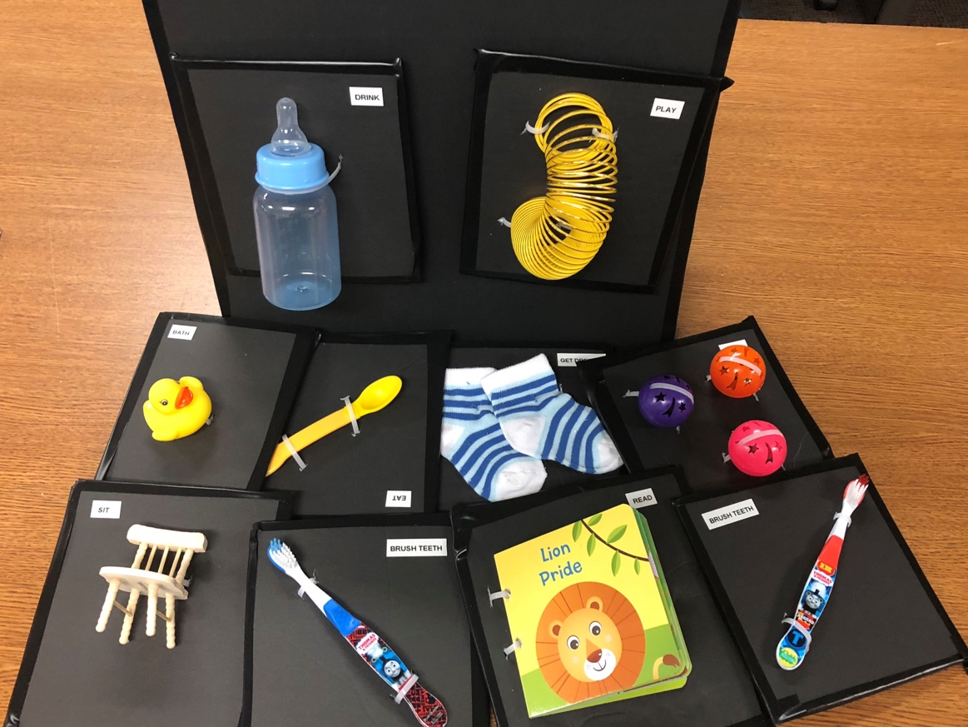

## Object Symbols – [year]

[insert photo of object & information to draw attention to]

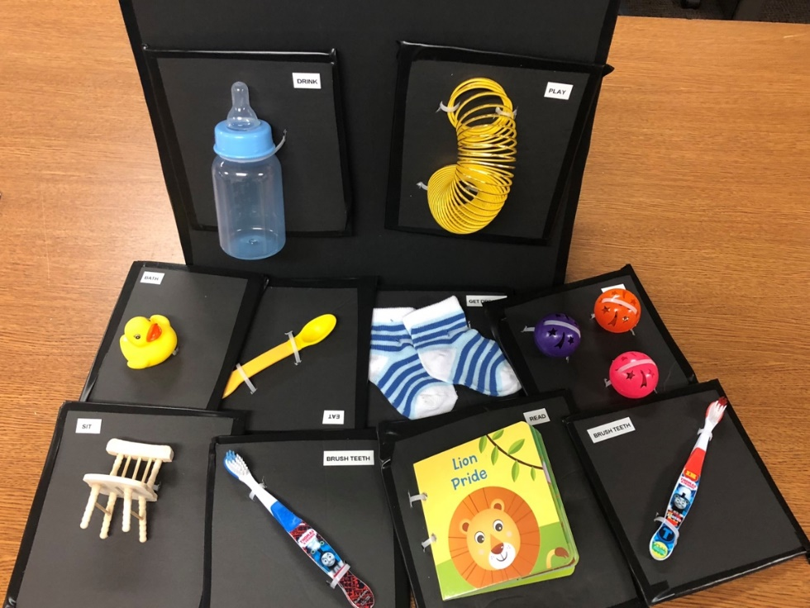

| Object | Represents |
| --- | --- |
|  |  |
|  |  |
|  |  |
|  |  |
|  |  |
|  |  |
|  |  |
|  |  |

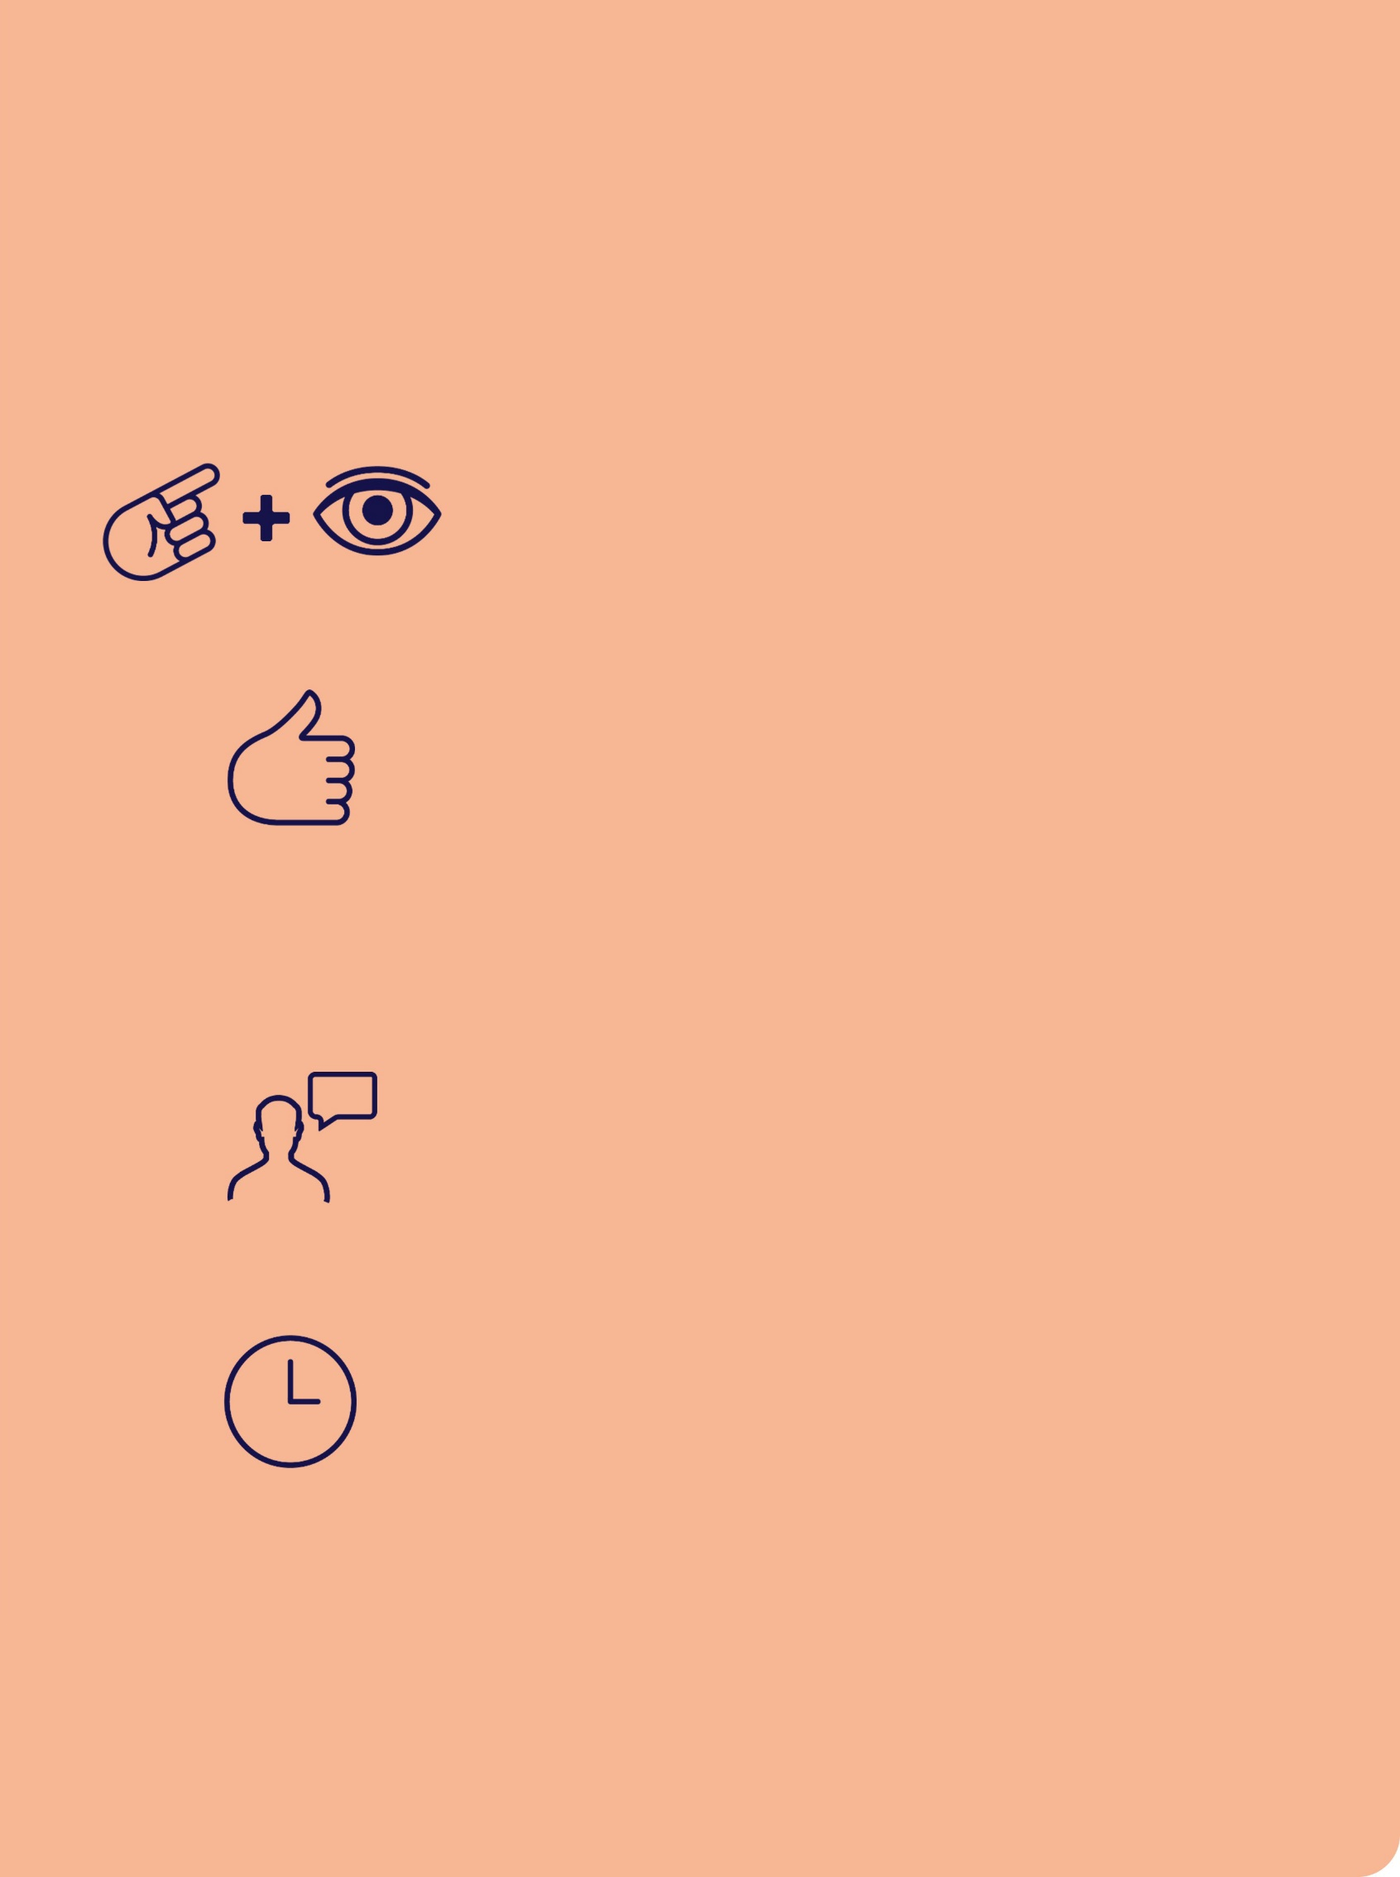Object Symbols

You can help teach the meaning of these symbols

Present

Show or give item and give time to explore

Sign

Sign what the object represents

### +

Say

Say what the activity/person/place is

When?

Just BEFORE the activity begins / person a­­rrives / going to the place **and** DURING the event

## Communication routines

What are communication routines?

Communication routines can be used to support a sequence of familiar events and provide opportunity to initiate interactions and learn language in context.

Why use them?

Communication routines are particularly useful for supporting [Name]’s communication, given their hearing and vision impairment. They help them to understand what will happen next.

How does [Name] use them?

[Name] uses communication routines to engage shared activities with others. It’s an opportunity to support their independence and learn signs in the context of familiar activities

Supporting communication routines

|  |  |
| --- | --- |
| Checkmark with solid fill | **Get ready**  Plan a clear beginning, middle, and end of routine.  Take your time and avoid rushing the steps of the routine. |
| **User outline** | **Plan communication**  Think about how the person communicates - use the right ways to communicate |
| Hand under hand icon | **Offer just enough support**  Encourage the person to do as much as possible independently   * Stop and wait * Point/show the next step * Demonstrate the next step   Offer steps of the routine in the same way to build familiarity  Share steps in a routine using hand under hand approach  Aim to reduce your support over time |

Supporting [Name]’s interaction in routines

[add or delete text according to individual’s communication & strategies]

* Involve [name] in all aspects of routine, from start to finish
* Ask if they need help and offer support.
* Use gesture and sign to indicate next step in routine.
* Wait and give time and space for independent activity.
* Offer help & information with a level matched to their need (listed less support to most support)
  + Describing (sign e.g., ‘turn on’), wait
  + Point, wait,
  + Show/model, wait,
  + Hand under hand, wait,
  + Do together (coactive movement).
* Stop/start activity & communicate “on, stop, turn, more/finish” etc.
* Have something to communicate about - photo book - talk about photos - naming people, events, places.
* Offer options to choose end of activity/next activity - give [name] control of whether to end/when to end.

[Name]’s communication routines

### Routine name

[add text describing steps of routine]

Beginning

#### Middle

#### End

**Communication routine: videos**

## Communication routine: Videos

An internet connection is required to play the videos in the coming slides. Click the images to access each online video.



[Describe the stage of the routine in the video]

Disclaimer

The contents of these videos are private,   
and for training purposes for intended viewers only.

Any use of, interference with, disclosure or copying   
of this material is unauthorised and prohibited.

## Please note

This document should be read in conjunction with: (add or delete as required)

* Behaviour Support Plan
* Manual Handing Plan
* Mealtime Management plan
* Orientation & Mobility plan
* Transport plan
* Medication chart

## Other

[enter text]

## Suggestions for review

This Individual Communication Handbook is a   
working document. Please feel free to write any suggestions or updates on this page.

| Date | Suggested edit & by whom | Page |
| --- | --- | --- |
|  |  |  |
|  |  |  |
|  |  |  |
|  |  |  |
|  |  |  |
|  |  |  |
|  |  |  |
|  |  |  |
|  |  |  |

## Contact

[insert your logo here]

[enter contact details]

For more information about deafblindness go to [www.deafblindinformation.org.au](http://www.deafblindinformation.org.au/)



Graphic design and accessibility by   
[**KC & the Graphics Bandwagon**](https://www.kcandthegraphicsbandwagon.com.au/)

