

# Tactile Literacy

**Information Sheet**

Tactile literacy is a term for all the ways of using touch instead of using sight or hearing. It includes using touch for gathering and sharing information. It may include but is not limited to, tactile sign language or the use of braille for reading and writing.

For people who can’t see written text and/or hear spoken language well, touch helps them access information and develop skills. This information sheet explores

* how people who are blind or deafblind use their tactile sense everyday
* how to support this process
* descriptions of common applications of tactile literacy
* where to access more information, materials and support

Caleb 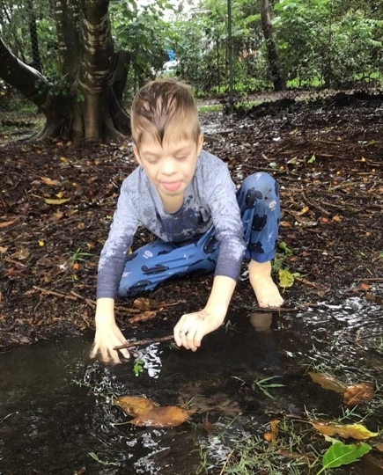 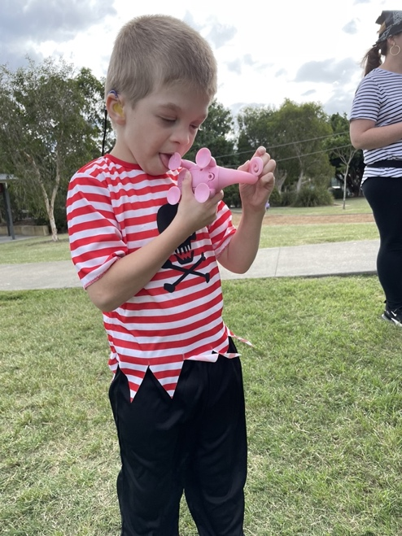 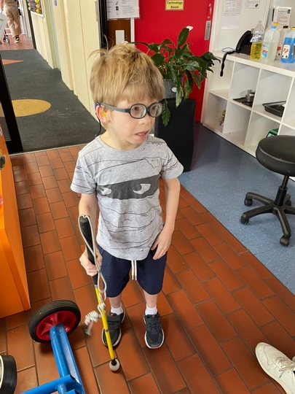

Caleb is quick and energetic. He loves lights, things that make sounds and enjoys music and dancing. He is curious about many things. Caleb uses his sense of touch to help him identify objects and understand his surroundings. He uses his hands a lot to do this. Touch helps him access signed communication. Caleb is creative with tactile literacy. As well as using his whole body, he also uses whatever is around him as a tool to assist tactile information gathering. In the photo on the left, Caleb is tapping around him with a small stick from a tree, to seek information about the puddle and surrounds. He also uses his mouth & tongue to explore and he is learning to use a white cane to check his path and navigate safely. Caleb is one of a small number of people in the world with TARP Syndrome. He has deafblindness.

## The Tactile Sense

#### Navigating the environment by touch

Many people with a vision impairment will gather information by touch. It is an action common in every aspect of their life. A person who is blind may touch all surfaces around them to identify their surroundings and location. They might do this with their hands. Their feet can also identify the ground textures such as carpet, tiles, gravel and other surfaces.

A cane can give information through touch about the ground immediately in front. It provides safety by making it easier to identify obstacles or hazards to move around. Tactile Ground Surface Indicators are often used at road crossings and stair wells in public buildings. They are a way of showing that a change to the ground level is immediately ahead.

When assisting a person who is blind to travel up or down stairs, help them locate the banister if they wish to use it. They can use their sense of touch to find out about the start, finish, direction and steepness of the stairs.

When you guide a person who is blind, allow them to take your elbow and follow a step behind. This way they gain important information from your speed and direction of travel and move efficiently past any:

* narrow spaces
* doorways
* steps
* kerbs

When a person who is blind drops an object, they will have to search by touch to find and retrieve it. Their environment should be kept consistent and clear of hazards. Placing items in an unexpected location creates the possibility of bumping into or tripping over this obstacle. Provide enough tactile information using hand-under-hand to guide their hand to the object and allow time to familiarise themself using touch.

#### Tactile adaptations in daily life

Many everyday items can feel exactly the same. Examples are

* shampoo and conditioner bottles
* canned foods
* bottles and jars

Using stickers that feel different or a rubber band, will help a person who is blind or deafblind differentiate between items. For example, having a rubber band around the shampoo bottle, but not around the conditioner bottle.

Appliances, such as a microwave have flat control panels. These are inaccessible for people who rely on touch to identify controls. Placing raised stick-on dots on the function keys can help a person who is blind to operate the appliance. Using different sized, textured and shaped dots helps the user tell the difference between the controls. Appliances like cookers and washing machines have several rotating controls, that all feel the same. Apply braille labels or different shaped raised stickers to mark temperatures or washing cycles. For example, a big square for power button, a small square for water level selector, and a large circle for start button.

Products designed for tactile users are available. Some of these include:

* braille watches and clocks, which allow a tactile user to feel the markings on the device to help them tell the time, and keep track of timers
* dot watches are smart watches which connect to other smart devices to provide alerts and notifications
* braille labellers enable the user to produce adhesive braille labels to apply to any item or appliance
* board and card games with braille such as Lego, Scrabble, and Monopoly
* board games with tactile markings such as snakes and ladders, chess, and Connect 4.

## Communication using the tactile sense

This is a summary of some communication methods using touch. Variations of these systems and new systems will also arise because of

* the uniqueness of each person’s situation
* their physical abilities
* their sensory abilities
* when in their life they become blind or deafblind

#### Objects of Reference

An object of reference is an everyday object or part of an object. It is used to represent an activity or other information. The object is paired with the activity, place, situation, person or activity. It may help the user understand what the object represents. Often individuals will recognise the object from using it during activities so it will be familiar and recognisable. For early communicators with deafblindness, real objects are usually more meaningful. Miniatures or abstract representations are harder to recognise.

Objects of reference can help people understand what is happening and help them to communicate with others. They are often used with people with blindness and deafblindness with cognitive disability. They can also help those who are at an early stage of communication development. Examples of objects of reference could be

* a washcloth means shower time
* a bowl and spoon means mealtime
* a teddy bear for bedtime
* a distinctive ribbon represents a particular person
* a piece of seat belt means we are going in the car

Choices of objects of reference should be meaningful to the person using them. Choosing them for an individual is more helpful than choosing for people you don't know.

There are other names for objects of reference. These are “object symbols” and “tangible symbols”.

Objects of reference can be used in a calendar system. Items may be mounted on a card, displayed on a board or in a sequence of boxes or compartments. Each object represents an activity and communicates the sequence of events over a period of time. The user can also select objects to show preferences and choices about activities, places and people.

Various disability organisations and service providers who have Speech Pathologists and Occupational Therapists can assist you to choose and design well-matched object symbol and calendar systems. Those working in blindness and low vision services can provide specialist help for someone with blindness or low vision, who may be accessing the system using residual vision, touch or a combination of both.

#### 3D Universal Core Vocabulary Symbols

#### The 3D Universal Core Vocabulary Symbols are a set of 36 three-dimensional abstract objects. Each of these objects or symbols represents a common word used in spoken language. Each symbol has a different combination of shape, colour, raised tactile marker, an indent of the printed word and the word in braille.

#### The set of symbols and the program to implement them was developed by Project Core. This is part of the Centre for Literacy and Disability Studies in North Carolina, USA.

#### Touch cues

Touch cues are an early form of tactile communication. They signal to someone via a specific touch on their body. The meaning of the touch cue tells what is about to happen or indicates a particular person is with them. Like objects of reference, the system of touch cues is developed for an individual and what is meaningful to them. Some examples are

* double tap on each hip bone = nappy change
* brushing hands up someone’s torso = I’m going to pick you up
* a double squeeze on the shoulder = I’m going somewhere, but I’ll be back soon
* tap on the foot = I’m going to put your shoe on

#### Sign language and touch

People who cannot access signed communication with sight, may do so through touch. Signs are made under a person’s hands. Then they can feel the movement, hand shape, orientation and location of the signs.

Deafblind alphabets are tactile adaptations of a signed alphabet. Letters are signed into the hand of the person with deafblindness. The Lorm alphabet consists of its own unique series of taps and strokes made onto the hand. It is used in parts of Europe. In Australia, the Deafblind alphabet is based on the Auslan alphabet.

Social haptics use touch to add to communication for deafblind. This system of signals passes on information that others would rely on sight for. Social haptic messages may be about facial expression, a map of a room or something else. The conversation does not have to stop, while information about the surroundings or about other people’s facial expressions is communicated.

Protactile combines tactile sign with a set of practices to make tactile communication more meaningful for people with deafblindness. Communication partners are in constant contact with one another throughout any conversation or shared experience. Information is gained directly from the source, as much as possible, rather than being relayed by the communication partner or interpreter. Communication takes place by touch and movement. The main areas of the body for this are the hands, wrist, elbow, arm, upper back. When in a seated position, it includes the knees and the top of the thigh. These are known as “contact spaces”. Protactile is gaining recognition as a distinct language, with an associated culture and philosophy.

#### Vibration and other tactile forms

Communication systems based on vibration are being researched. Examples include morse code, braille and deafblind alphabets converted to vibrating tactile signals.

Tadoma is a method that uses touch on specific parts of the face and throat to understand speech. Movement, vocal vibration and the breath stream are felt.

The Block Alphabet is a tactile adaption of the written alphabet, where capital letters are traced into the palm to spell words.

## Reading and writing using touch

#### Moon

Moon is a tactile reading format which consists of dots similar to braille dots and are read similarly by tracing the fingertips along the lines of characters. The symbols are structured similarly to print letters and they are larger than braille characters. The unabbreviated version of Moon is called Grade 1 where the words are written letter for letter.

Grade 2 incorporates abbreviations signs which represent commonly grouped letters. The use of these abbreviations help to reduce the amount of characters required, and condenses text resulting in faster reading for those proficient in Moon. The [Braille House](https://www.braillehouse.org.au/library/) in Brisbane, Australia produces materials in Moon.

#### Braille

Braille is a reading system based on cells of 6 dots which are arranged in to symbols which represent letters, numbers and punctuation. Braille is read by tracing the fingertips along the rows of characters.

The symbols are much smaller than those of moon but are larger than the size of standard print. Braille characters are structured very differently to those of the moon and print alphabets.

Braille has two levels called Grade 1 and Grade 2. Grade 1 does not contain any abbreviations. All words are written letter for letter.

Grade 2 is more advanced, using abbreviations which represent commonly grouped letters, reducing characters required and helps to condense text.

The [Australian Braille Authority](https://brailleaustralia.org/) has a [Braille Directory](https://brailleaustralia.org/finding-braille/directory/) which lists major suppliers of braille services and products in Australia.

## Information & support in Australia

Orientation and Mobility Instructors and Occupational Therapists with experience in providing Blind and Low Vision services and Specialist Teachers in vision impairment can assist in development of tactile literacy. They can also suggest related assistive technology services and suppliers. Other members of the team, where vision and hearing impairment occur together include:

* Deafblind Consultant
* Communication Guide
* Specialist Teacher/s (Deafblindness/Sensory Impairment)

The [Feelix Children’s Library](https://www.visionaustralia.org/services/library/feelix-childrens-library) is a free library service for Australian children with blindness or low vision and provides books in various formats, including storybook kits that contain tactile books. Tactile books use objects to help tell the story, instead of pictures. The library has a large collection of literacy materials to loan, from story packs to multi-volume novels in braille.

State based education departments also usually have braille production and tactile literacy services.

Vision Australia library members are eligible for the [Personal support service](https://www.visionaustralia.org/business-consulting/print-accessibility/alternate-format-production) which provides the transcription of up to 360 pages of information into alternative reading formats like braille, audio, large print or e-text, each financial year. This is funded by an Australian Federal government grant.

A bibliography is provided on the following pages of this information sheet.

Published: December 2023

Bibliography

Adkins, A., Kitchen, S., & Sewell, D. (2022). The Early Tactile Learning Profile*. TX SenseAbilities (Spring).* <https://www.tsbvi.edu/tx-senseabilities/issues/tx-senseabilities-spring-2022-issue/the-early-tactile-learning-profile>

Block Alphabet. (n.d.). Deafblind Information Australia. <https://www.deafblindinformation.org.au/living-with-deafblindness/deafblind-communication/block-alphabet/>

Clark, J.L. and Nuccio, J.B. (2020). Protactile Linguistics: Discussing recent research findings. *Journal of American Sign Languages and Literatures*. <https://journalofasl.com/protactile-linguistics/>

Deafblind Manual Alphabet. (n.d.). Deafblind Information Australia. <https://www.deafblindinformation.org.au/living-with-deafblindness/deafblind-communication/deafblind-manual-alphabet/>

Directory of braille services and products in Australia (n.d.). Australian Braille Authority. <https://brailleaustralia.org/finding-braille/directory/>

Fakoó, A. (n.d.). *The Lorm Alphabet*. FAKOO DE/EN. <https://fakoo.de/en/lorm.html>

Fakoó, A. (n.d.). *The Moon Alphabet*. FAKOO DE/EN. <https://fakoo.de/en/moon.html>

Feelix Children’s Library. (n.d.). Vision Australia. <https://www.visionaustralia.org/services/library/feelix-childrens-library>

Granda, aj. & Nuccio, J. (2018). *Protactile Principles.* [16 page document]. Tactile Communications. <https://www.tactilecommunications.org/Documents/PTPrinciplesMoviesFinal.pdf>

Helen Keller National Centre. (n.d.). *Haptics Video Series.* <https://www.helenkeller.org/resources/haptics-video-series/>

Helpful information (n.d.). Braille House. <https://www.braillehouse.org.au/contact/links/>

Hesse, P. & Nielsen, G. (2018). *Haptic Signals: 139 new and known signals*. [163 page document]. Danish DeafBlind Association. <https://www.fddb.dk/media/141088/haptic-signals-139-new-and-known-signals-english.pdf>

Kasimova, E., & Kutlubaeva, R. (2020). Teaching The Lorm Alphabet To Adults With Deaf-Blindness Acquired With Age. In I. Murzina (Ed.), *Humanistic Practice in Education in a Postmodern Age*, *93*. (pp. 514-525). European Proceedings of Social and Behavioural Sciences European Publisher. <https://doi.org/10.15405/epsbs.2020.11.53>

Leland, A. (2022, May 12). Deafblind communities may be creating a new language of touch. *The New Yorker.* <https://www.newyorker.com/culture/annals-of-inquiry/deafblind-communities-may-be-creating-a-new-language-of-touch>

Plaisier, M.A., Vermeer, D.S. & Kappers, A.M.L. (2020). Learning the Vibrotactile Morse Code Alphabet. *ACM Transactions on Applied Perception,* *17*(3), 1-10. <https://doi.org/10.1145/3402935>

Nichols De Grant, J. (n.d.). The Power of Communicating with Tactile Symbols. *Paths to Literacy Learning Resources Blog*. <https://www.pathstoliteracy.org/power-communicating-tactile-symbols/>

Reed, C.M., Rabinowitz, W.M., Durlach,N.I., Braida, L.D., Conway-Fithian, S., & Schultz, M.C. (1985). Research on the Tadoma method of speech communication. *J Acoust Soc Am. 77*(1), 247-257. <https://doi.org/10.1121/1.392266>

Reed, C.M., Hong, T.Z., & Jones, L.A. (2023). Haptic Communication of Language. *IEEE Transactions on Haptics 16* (2), 134-153. <https://doi.org/10.1109/TOH.2023.3257539>

Rowland, C. & Schweigert, P. (n.d.). *Tangible Symbol Systems Primer* [20 page document]. Design to Learn. <https://www.designtolearn.com/uploaded/pdf/Tangible-Symbols-Primer-07-09x.pdf>

Russ Palmer Riitta Lahtinen. (n.d.). *Social-Haptic Communication.* <https://www.russpalmer.com/social-haptic-communication>

sense. (2023, April). *Objects of reference.* <https://www.sense.org.uk/information-and-advice/communication/objects-of-reference/>

The Index Project. (n.d). *Lorm Hand: A Communication Device for Deaf-Blind People.* <https://theindexproject.org/award/nominees/1228>

The Research. (n.d.). Anne. <https://www.anneapp.com/#research>

Universal Core Vocabulary – 3D Symbol Format. (2020, January). Project Core. <https://www.project-core.com/3d-symbols/>

Welcome to the Braille Bug. (n.d.). *What is Braille: Deciphering the Code.* <https://braillebug.org/braille/braille-deciphering/>

End of document.